

Relational Database

Developed from IMDB data sets



Table of Contents

**1: Description of dataset2**

**2: Database Design (ERD)3**

**3: Database Schema4**

**4: Normal Forms 28**

3rd normal Form29

Boyce–code Normal Form (BCNF) 30

4th Normal Form 31

**5: Queries 32**

**6: Applications/Use cases47**

**Links/ References 56**

**Question No.1**

**Description of Dataset:**

The dataset provides information about the top one thousand movies and television shows according to IMDb. This dataset is utilized to generate the database.

**Poster_Link:** It has links to the posters of the movies.

**Series_Title:** This column includes the movie name.

**ReleasedYear**: It shows the release year of the movie.

**Certificate:** This column shows the certificate that is earned by the movie.

**Runtime:** It shows the movie runtime in minute,

**Genre:** This column specifies the genre of movies.

**IMDB_Rating:** It provides the rating of the movies.

**Overview:** It has a brief summary or synopsis.

**Metascore:** It shows the score that a movie has earned.

**Director:** This column shows the name of the director(s).

**No_of_votes:** It represents the total number of votes that a movie has received.

**Gross:** This column shows the amount earned by the movie in of gross revenue.

This dataset covers various aspects related to movies and TV shows. It has applications in the fields of entertainment and media research and analysis.

The users interact with a database that has movie data and related genres. At first, users can perform genre-based searches or get specific movie facts by inserting commands or queries. In order to retrieve essential movie attributes and their respective genres, the system queries the Movies table in response to these operations. The MovieGenre table makes it easier to get genre information associated with particular films. The user can view, examine, and update the movie data as needed once the system retrieves what they need and provides it to them. This optimized flow guarantees quick access to extensive movie data, enabling visitors to easily explore and engage with cinematic content.

**Question No. 2**

**Database Design**

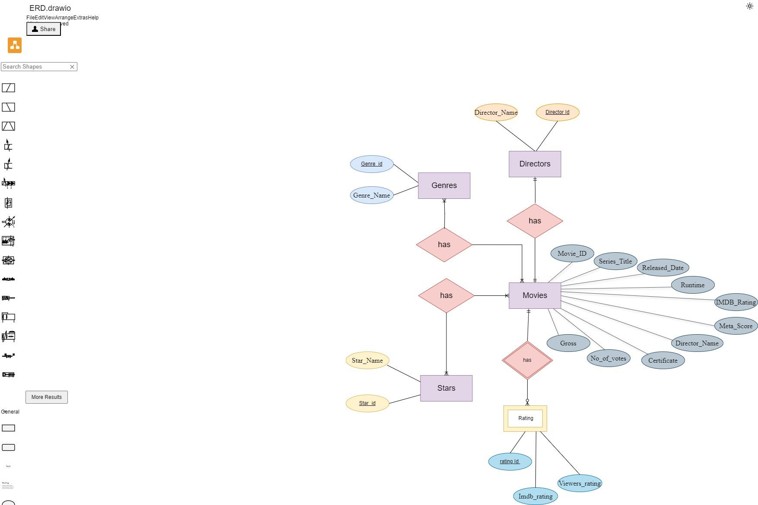

**Question No.3**

Database Schema and Data

|  |
| --- |
| USE [imdb]  GO  /****** Object: Table [dbo].[Directors] Script Date: 09/04/2024 07:31:29 AM ******/  SET ANSI_NULLS ON  GO  SET QUOTED_IDENTIFIER ON  GO  CREATE TABLE [dbo].[Directors](  [director_id] [tinyint] NOT NULL,  [Director] [nvarchar](50) NOT NULL,  CONSTRAINT [PK_Directors] PRIMARY KEY CLUSTERED  (  [director_id] ASC  )WITH (PAD_INDEX = OFF, STATISTICS_NORECOMPUTE = OFF, IGNORE_DUP_KEY = OFF, ALLOW_ROW_LOCKS = ON, ALLOW_PAGE_LOCKS = ON, OPTIMIZE_FOR_SEQUENTIAL_KEY = OFF) ON [PRIMARY]  ) ON [PRIMARY]  GO  /****** Object: Table [dbo].[Genres] Script Date: 09/04/2024 07:31:29 AM ******/  SET ANSI_NULLS ON  GO  SET QUOTED_IDENTIFIER ON  GO  CREATE TABLE [dbo].[Genres](  [genre_id] [tinyint] NOT NULL,  [Genre] [nvarchar](50) NOT NULL,  CONSTRAINT [PK_Genres] PRIMARY KEY CLUSTERED  (  [genre_id] ASC  )WITH (PAD_INDEX = OFF, STATISTICS_NORECOMPUTE = OFF, IGNORE_DUP_KEY = OFF, ALLOW_ROW_LOCKS = ON, ALLOW_PAGE_LOCKS = ON, OPTIMIZE_FOR_SEQUENTIAL_KEY = OFF) ON [PRIMARY]  ) ON [PRIMARY]  GO  /****** Object: Table [dbo].[MovieGenre] Script Date: 09/04/2024 07:31:29 AM ******/  SET ANSI_NULLS ON  GO  SET QUOTED_IDENTIFIER ON  GO  CREATE TABLE [dbo].[MovieGenre](  [movie_id] [tinyint] NOT NULL,  [genre_id] [tinyint] NOT NULL,  CONSTRAINT [PK_MovieGenre] PRIMARY KEY CLUSTERED  (  [movie_id] ASC  )WITH (PAD_INDEX = OFF, STATISTICS_NORECOMPUTE = OFF, IGNORE_DUP_KEY = OFF, ALLOW_ROW_LOCKS = ON, ALLOW_PAGE_LOCKS = ON, OPTIMIZE_FOR_SEQUENTIAL_KEY = OFF) ON [PRIMARY]  ) ON [PRIMARY]  GO  /****** Object: Table [dbo].[Movies] Script Date: 09/04/2024 07:31:29 AM ******/  SET ANSI_NULLS ON  GO  SET QUOTED_IDENTIFIER ON  GO  CREATE TABLE [dbo].[Movies](  [movie_id] [tinyint] NOT NULL,  [Poster_Link] [nvarchar](200) NOT NULL,  [Series_Title] [nvarchar](100) NOT NULL,  [Released_Year] [smallint] NOT NULL,  [Certificate] [nvarchar](50) NULL,  [Runtime] [nvarchar](50) NOT NULL,  [Metascore] [tinyint] NULL,  [No_of_Votes] [int] NOT NULL,  [Gross] [int] NULL,  CONSTRAINT [PK_Movies] PRIMARY KEY CLUSTERED  (  [movie_id] ASC  )WITH (PAD_INDEX = OFF, STATISTICS_NORECOMPUTE = OFF, IGNORE_DUP_KEY = OFF, ALLOW_ROW_LOCKS = ON, ALLOW_PAGE_LOCKS = ON, OPTIMIZE_FOR_SEQUENTIAL_KEY = OFF) ON [PRIMARY]  ) ON [PRIMARY]  GO  /****** Object: Table [dbo].[stars] Script Date: 09/04/2024 07:31:29 AM ******/  SET ANSI_NULLS ON  GO  SET QUOTED_IDENTIFIER ON  GO  CREATE TABLE [dbo].[stars](  [stars_id] [tinyint] NOT NULL,  [StarName] [nvarchar](50) NOT NULL,  CONSTRAINT [PK_stars] PRIMARY KEY CLUSTERED  (  [stars_id] ASC  )WITH (PAD_INDEX = OFF, STATISTICS_NORECOMPUTE = OFF, IGNORE_DUP_KEY = OFF, ALLOW_ROW_LOCKS = ON, ALLOW_PAGE_LOCKS = ON, OPTIMIZE_FOR_SEQUENTIAL_KEY = OFF) ON [PRIMARY]  ) ON [PRIMARY]  GO  INSERT [dbo].[Directors] ([director_id], [Director]) VALUES (1, N'Frank Darabont')  INSERT [dbo].[Directors] ([director_id], [Director]) VALUES (2, N'Francis Ford Coppola')  INSERT [dbo].[Directors] ([director_id], [Director]) VALUES (3, N'Christopher Nolan')  INSERT [dbo].[Directors] ([director_id], [Director]) VALUES (4, N'Francis Ford Coppola')  INSERT [dbo].[Directors] ([director_id], [Director]) VALUES (5, N'Sidney Lumet')  INSERT [dbo].[Directors] ([director_id], [Director]) VALUES (6, N'Peter Jackson')  INSERT [dbo].[Directors] ([director_id], [Director]) VALUES (7, N'Quentin Tarantino')  INSERT [dbo].[Directors] ([director_id], [Director]) VALUES (8, N'Steven Spielberg')  INSERT [dbo].[Directors] ([director_id], [Director]) VALUES (9, N'Christopher Nolan')  INSERT [dbo].[Directors] ([director_id], [Director]) VALUES (10, N'David Fincher')  INSERT [dbo].[Directors] ([director_id], [Director]) VALUES (11, N'Peter Jackson')  INSERT [dbo].[Directors] ([director_id], [Director]) VALUES (12, N'Robert Zemeckis')  INSERT [dbo].[Directors] ([director_id], [Director]) VALUES (13, N'Sergio Leone')  INSERT [dbo].[Directors] ([director_id], [Director]) VALUES (14, N'Peter Jackson')  INSERT [dbo].[Directors] ([director_id], [Director]) VALUES (15, N'Lana Wachowski')  INSERT [dbo].[Directors] ([director_id], [Director]) VALUES (16, N'Martin Scorsese')  INSERT [dbo].[Directors] ([director_id], [Director]) VALUES (17, N'Irvin Kershner')  INSERT [dbo].[Directors] ([director_id], [Director]) VALUES (18, N'Milos Forman')  INSERT [dbo].[Directors] ([director_id], [Director]) VALUES (19, N'Thomas Kail')  INSERT [dbo].[Directors] ([director_id], [Director]) VALUES (20, N'Bong Joon Ho')  INSERT [dbo].[Directors] ([director_id], [Director]) VALUES (21, N'Sudha Kongara')  INSERT [dbo].[Directors] ([director_id], [Director]) VALUES (22, N'Christopher Nolan')  INSERT [dbo].[Directors] ([director_id], [Director]) VALUES (23, N'Fernando Meirelles')  INSERT [dbo].[Directors] ([director_id], [Director]) VALUES (24, N'Hayao Miyazaki')  INSERT [dbo].[Directors] ([director_id], [Director]) VALUES (25, N'Steven Spielberg')  INSERT [dbo].[Directors] ([director_id], [Director]) VALUES (26, N'Frank Darabont')  INSERT [dbo].[Directors] ([director_id], [Director]) VALUES (27, N'Roberto Benigni')  INSERT [dbo].[Directors] ([director_id], [Director]) VALUES (28, N'David Fincher')  INSERT [dbo].[Directors] ([director_id], [Director]) VALUES (29, N'Jonathan Demme')  INSERT [dbo].[Directors] ([director_id], [Director]) VALUES (30, N'George Lucas')  INSERT [dbo].[Directors] ([director_id], [Director]) VALUES (31, N'Masaki Kobayashi')  INSERT [dbo].[Directors] ([director_id], [Director]) VALUES (32, N'Akira Kurosawa')  INSERT [dbo].[Directors] ([director_id], [Director]) VALUES (33, N'Frank Capra')  INSERT [dbo].[Directors] ([director_id], [Director]) VALUES (34, N'Todd Phillips')  INSERT [dbo].[Directors] ([director_id], [Director]) VALUES (35, N'Damien Chazelle')  INSERT [dbo].[Directors] ([director_id], [Director]) VALUES (36, N'Olivier Nakache')  INSERT [dbo].[Directors] ([director_id], [Director]) VALUES (37, N'Christopher Nolan')  INSERT [dbo].[Directors] ([director_id], [Director]) VALUES (38, N'Martin Scorsese')  INSERT [dbo].[Directors] ([director_id], [Director]) VALUES (39, N'Roman Polanski')  INSERT [dbo].[Directors] ([director_id], [Director]) VALUES (40, N'Ridley Scott')  INSERT [dbo].[Directors] ([director_id], [Director]) VALUES (41, N'Tony Kaye')  INSERT [dbo].[Directors] ([director_id], [Director]) VALUES (42, N'Bryan Singer')  INSERT [dbo].[Directors] ([director_id], [Director]) VALUES (43, N'Luc Besson')  INSERT [dbo].[Directors] ([director_id], [Director]) VALUES (44, N'Roger Allers')  INSERT [dbo].[Directors] ([director_id], [Director]) VALUES (45, N'James Cameron')  INSERT [dbo].[Directors] ([director_id], [Director]) VALUES (46, N'Giuseppe Tornatore')  INSERT [dbo].[Directors] ([director_id], [Director]) VALUES (47, N'Isao Takahata')  INSERT [dbo].[Directors] ([director_id], [Director]) VALUES (48, N'Robert Zemeckis')  INSERT [dbo].[Directors] ([director_id], [Director]) VALUES (49, N'Sergio Leone')  INSERT [dbo].[Directors] ([director_id], [Director]) VALUES (50, N'Alfred Hitchcock')  INSERT [dbo].[Directors] ([director_id], [Director]) VALUES (51, N'Michael Curtiz')  INSERT [dbo].[Directors] ([director_id], [Director]) VALUES (52, N'Charles Chaplin')  INSERT [dbo].[Directors] ([director_id], [Director]) VALUES (53, N'Charles Chaplin')  INSERT [dbo].[Directors] ([director_id], [Director]) VALUES (54, N'Nadine Labaki')  INSERT [dbo].[Directors] ([director_id], [Director]) VALUES (55, N'Can Ulkay')  INSERT [dbo].[Directors] ([director_id], [Director]) VALUES (56, N'Gayatri')  INSERT [dbo].[Directors] ([director_id], [Director]) VALUES (57, N'Makoto Shinkai')  INSERT [dbo].[Directors] ([director_id], [Director]) VALUES (58, N'Nitesh Tiwari')  INSERT [dbo].[Directors] ([director_id], [Director]) VALUES (59, N'Bob Persichetti')  INSERT [dbo].[Directors] ([director_id], [Director]) VALUES (60, N'Anthony Russo')  INSERT [dbo].[Directors] ([director_id], [Director]) VALUES (61, N'Anthony Russo')  INSERT [dbo].[Directors] ([director_id], [Director]) VALUES (62, N'Lee Unkrich')  INSERT [dbo].[Directors] ([director_id], [Director]) VALUES (63, N'Quentin Tarantino')  INSERT [dbo].[Directors] ([director_id], [Director]) VALUES (64, N'Christopher Nolan')  INSERT [dbo].[Directors] ([director_id], [Director]) VALUES (65, N'Rajkumar Hirani')  INSERT [dbo].[Directors] ([director_id], [Director]) VALUES (66, N'Aamir Khan')  INSERT [dbo].[Directors] ([director_id], [Director]) VALUES (67, N'Andrew Stanton')  INSERT [dbo].[Directors] ([director_id], [Director]) VALUES (68, N'Florian Henckel von Donnersmarck')  INSERT [dbo].[Directors] ([director_id], [Director]) VALUES (69, N'Chan-wook Park')  INSERT [dbo].[Directors] ([director_id], [Director]) VALUES (70, N'Christopher Nolan')  INSERT [dbo].[Directors] ([director_id], [Director]) VALUES (71, N'Hayao Miyazaki')  INSERT [dbo].[Directors] ([director_id], [Director]) VALUES (72, N'Sergio Leone')  INSERT [dbo].[Directors] ([director_id], [Director]) VALUES (73, N'Steven Spielberg')  INSERT [dbo].[Directors] ([director_id], [Director]) VALUES (74, N'Stanley Kubrick')  INSERT [dbo].[Directors] ([director_id], [Director]) VALUES (75, N'Francis Ford Coppola')  INSERT [dbo].[Directors] ([director_id], [Director]) VALUES (76, N'Ridley Scott')  INSERT [dbo].[Directors] ([director_id], [Director]) VALUES (77, N'Hrishikesh Mukherjee')  INSERT [dbo].[Directors] ([director_id], [Director]) VALUES (78, N'Akira Kurosawa')  INSERT [dbo].[Directors] ([director_id], [Director]) VALUES (79, N'Stanley Kubrick')  INSERT [dbo].[Directors] ([director_id], [Director]) VALUES (80, N'Billy Wilder')  GO  INSERT [dbo].[Genres] ([genre_id], [Genre]) VALUES (1, N'Drama')  INSERT [dbo].[Genres] ([genre_id], [Genre]) VALUES (2, N'Crime, Drama')  INSERT [dbo].[Genres] ([genre_id], [Genre]) VALUES (3, N'Action, Crime, Drama')  INSERT [dbo].[Genres] ([genre_id], [Genre]) VALUES (4, N'Crime, Drama')  INSERT [dbo].[Genres] ([genre_id], [Genre]) VALUES (5, N'Crime, Drama')  INSERT [dbo].[Genres] ([genre_id], [Genre]) VALUES (6, N'Action, Adventure, Drama')  INSERT [dbo].[Genres] ([genre_id], [Genre]) VALUES (7, N'Crime, Drama')  INSERT [dbo].[Genres] ([genre_id], [Genre]) VALUES (8, N'Biography, Drama, History')  INSERT [dbo].[Genres] ([genre_id], [Genre]) VALUES (9, N'Action, Adventure, Sci-Fi')  INSERT [dbo].[Genres] ([genre_id], [Genre]) VALUES (10, N'Drama')  INSERT [dbo].[Genres] ([genre_id], [Genre]) VALUES (11, N'Action, Adventure, Drama')  INSERT [dbo].[Genres] ([genre_id], [Genre]) VALUES (12, N'Drama, Romance')  INSERT [dbo].[Genres] ([genre_id], [Genre]) VALUES (13, N'Western')  INSERT [dbo].[Genres] ([genre_id], [Genre]) VALUES (14, N'Action, Adventure, Drama')  INSERT [dbo].[Genres] ([genre_id], [Genre]) VALUES (15, N'Action, Sci-Fi')  INSERT [dbo].[Genres] ([genre_id], [Genre]) VALUES (16, N'Biography, Crime, Drama')  INSERT [dbo].[Genres] ([genre_id], [Genre]) VALUES (17, N'Action, Adventure, Fantasy')  INSERT [dbo].[Genres] ([genre_id], [Genre]) VALUES (18, N'Drama')  INSERT [dbo].[Genres] ([genre_id], [Genre]) VALUES (19, N'Biography, Drama, History')  INSERT [dbo].[Genres] ([genre_id], [Genre]) VALUES (20, N'Comedy, Drama, Thriller')  INSERT [dbo].[Genres] ([genre_id], [Genre]) VALUES (21, N'Drama')  INSERT [dbo].[Genres] ([genre_id], [Genre]) VALUES (22, N'Adventure, Drama, Sci-Fi')  INSERT [dbo].[Genres] ([genre_id], [Genre]) VALUES (23, N'Crime, Drama')  INSERT [dbo].[Genres] ([genre_id], [Genre]) VALUES (24, N'Animation, Adventure, Family')  INSERT [dbo].[Genres] ([genre_id], [Genre]) VALUES (25, N'Drama, War')  INSERT [dbo].[Genres] ([genre_id], [Genre]) VALUES (26, N'Crime, Drama, Fantasy')  INSERT [dbo].[Genres] ([genre_id], [Genre]) VALUES (27, N'Comedy, Drama, Romance')  INSERT [dbo].[Genres] ([genre_id], [Genre]) VALUES (28, N'Crime, Drama, Mystery')  INSERT [dbo].[Genres] ([genre_id], [Genre]) VALUES (29, N'Crime, Drama, Thriller')  INSERT [dbo].[Genres] ([genre_id], [Genre]) VALUES (30, N'Action, Adventure, Fantasy')  INSERT [dbo].[Genres] ([genre_id], [Genre]) VALUES (31, N'Action, Drama, Mystery')  INSERT [dbo].[Genres] ([genre_id], [Genre]) VALUES (32, N'Action, Adventure, Drama')  INSERT [dbo].[Genres] ([genre_id], [Genre]) VALUES (33, N'Drama, Family, Fantasy')  INSERT [dbo].[Genres] ([genre_id], [Genre]) VALUES (34, N'Crime, Drama, Thriller')  INSERT [dbo].[Genres] ([genre_id], [Genre]) VALUES (35, N'Drama, Music')  INSERT [dbo].[Genres] ([genre_id], [Genre]) VALUES (36, N'Biography, Comedy, Drama')  INSERT [dbo].[Genres] ([genre_id], [Genre]) VALUES (37, N'Drama, Mystery, Sci-Fi')  INSERT [dbo].[Genres] ([genre_id], [Genre]) VALUES (38, N'Crime, Drama, Thriller')  INSERT [dbo].[Genres] ([genre_id], [Genre]) VALUES (39, N'Biography, Drama, Music')  INSERT [dbo].[Genres] ([genre_id], [Genre]) VALUES (40, N'Action, Adventure, Drama')  INSERT [dbo].[Genres] ([genre_id], [Genre]) VALUES (41, N'Drama')  INSERT [dbo].[Genres] ([genre_id], [Genre]) VALUES (42, N'Crime, Mystery, Thriller')  INSERT [dbo].[Genres] ([genre_id], [Genre]) VALUES (43, N'Action, Crime, Drama')  INSERT [dbo].[Genres] ([genre_id], [Genre]) VALUES (44, N'Animation, Adventure, Drama')  INSERT [dbo].[Genres] ([genre_id], [Genre]) VALUES (45, N'Action, Sci-Fi')  INSERT [dbo].[Genres] ([genre_id], [Genre]) VALUES (46, N'Drama, Romance')  INSERT [dbo].[Genres] ([genre_id], [Genre]) VALUES (47, N'Animation, Drama, War')  INSERT [dbo].[Genres] ([genre_id], [Genre]) VALUES (48, N'Adventure, Comedy, Sci-Fi')  INSERT [dbo].[Genres] ([genre_id], [Genre]) VALUES (49, N'Western')  INSERT [dbo].[Genres] ([genre_id], [Genre]) VALUES (50, N'Horror, Mystery, Thriller')  INSERT [dbo].[Genres] ([genre_id], [Genre]) VALUES (51, N'Drama, Romance, War')  INSERT [dbo].[Genres] ([genre_id], [Genre]) VALUES (52, N'Comedy, Drama, Family')  INSERT [dbo].[Genres] ([genre_id], [Genre]) VALUES (53, N'Comedy, Drama, Romance')  INSERT [dbo].[Genres] ([genre_id], [Genre]) VALUES (54, N'Drama')  INSERT [dbo].[Genres] ([genre_id], [Genre]) VALUES (55, N'Biography, Drama, History')  INSERT [dbo].[Genres] ([genre_id], [Genre]) VALUES (56, N'Action, Crime, Drama')  INSERT [dbo].[Genres] ([genre_id], [Genre]) VALUES (57, N'Animation, Drama, Fantasy')  INSERT [dbo].[Genres] ([genre_id], [Genre]) VALUES (58, N'Action, Biography, Drama')  INSERT [dbo].[Genres] ([genre_id], [Genre]) VALUES (59, N'Animation, Action, Adventure')  INSERT [dbo].[Genres] ([genre_id], [Genre]) VALUES (60, N'Action, Adventure, Drama')  INSERT [dbo].[Genres] ([genre_id], [Genre]) VALUES (61, N'Action, Adventure, Sci-Fi')  INSERT [dbo].[Genres] ([genre_id], [Genre]) VALUES (62, N'Animation, Adventure, Family')  INSERT [dbo].[Genres] ([genre_id], [Genre]) VALUES (63, N'Drama, Western')  INSERT [dbo].[Genres] ([genre_id], [Genre]) VALUES (64, N'Action, Adventure')  INSERT [dbo].[Genres] ([genre_id], [Genre]) VALUES (65, N'Comedy, Drama')  INSERT [dbo].[Genres] ([genre_id], [Genre]) VALUES (66, N'Drama, Family')  INSERT [dbo].[Genres] ([genre_id], [Genre]) VALUES (67, N'Animation, Adventure, Family')  INSERT [dbo].[Genres] ([genre_id], [Genre]) VALUES (68, N'Drama, Mystery, Thriller')  INSERT [dbo].[Genres] ([genre_id], [Genre]) VALUES (69, N'Action, Drama, Mystery')  INSERT [dbo].[Genres] ([genre_id], [Genre]) VALUES (70, N'Mystery, Thriller')  INSERT [dbo].[Genres] ([genre_id], [Genre]) VALUES (71, N'Animation, Action, Adventure')  INSERT [dbo].[Genres] ([genre_id], [Genre]) VALUES (72, N'Crime, Drama')  INSERT [dbo].[Genres] ([genre_id], [Genre]) VALUES (73, N'Action, Adventure')  INSERT [dbo].[Genres] ([genre_id], [Genre]) VALUES (74, N'Drama, Horror')  INSERT [dbo].[Genres] ([genre_id], [Genre]) VALUES (75, N'Drama, Mystery, War')  INSERT [dbo].[Genres] ([genre_id], [Genre]) VALUES (76, N'Horror, Sci-Fi')  INSERT [dbo].[Genres] ([genre_id], [Genre]) VALUES (77, N'Drama, Musical')  INSERT [dbo].[Genres] ([genre_id], [Genre]) VALUES (78, N'Crime, Drama, Mystery')  INSERT [dbo].[Genres] ([genre_id], [Genre]) VALUES (79, N'Comedy')  INSERT [dbo].[Genres] ([genre_id], [Genre]) VALUES (80, N'Crime, Drama, Mystery')  GO  INSERT [dbo].[MovieGenre] ([movie_id], [genre_id]) VALUES (1, 1)  INSERT [dbo].[MovieGenre] ([movie_id], [genre_id]) VALUES (2, 2)  INSERT [dbo].[MovieGenre] ([movie_id], [genre_id]) VALUES (3, 3)  INSERT [dbo].[MovieGenre] ([movie_id], [genre_id]) VALUES (4, 4)  INSERT [dbo].[MovieGenre] ([movie_id], [genre_id]) VALUES (5, 5)  INSERT [dbo].[MovieGenre] ([movie_id], [genre_id]) VALUES (6, 6)  INSERT [dbo].[MovieGenre] ([movie_id], [genre_id]) VALUES (7, 7)  INSERT [dbo].[MovieGenre] ([movie_id], [genre_id]) VALUES (8, 8)  INSERT [dbo].[MovieGenre] ([movie_id], [genre_id]) VALUES (9, 9)  INSERT [dbo].[MovieGenre] ([movie_id], [genre_id]) VALUES (10, 10)  INSERT [dbo].[MovieGenre] ([movie_id], [genre_id]) VALUES (11, 11)  INSERT [dbo].[MovieGenre] ([movie_id], [genre_id]) VALUES (12, 12)  INSERT [dbo].[MovieGenre] ([movie_id], [genre_id]) VALUES (13, 13)  INSERT [dbo].[MovieGenre] ([movie_id], [genre_id]) VALUES (14, 14)  INSERT [dbo].[MovieGenre] ([movie_id], [genre_id]) VALUES (15, 15)  INSERT [dbo].[MovieGenre] ([movie_id], [genre_id]) VALUES (16, 16)  INSERT [dbo].[MovieGenre] ([movie_id], [genre_id]) VALUES (17, 17)  INSERT [dbo].[MovieGenre] ([movie_id], [genre_id]) VALUES (18, 18)  INSERT [dbo].[MovieGenre] ([movie_id], [genre_id]) VALUES (19, 19)  INSERT [dbo].[MovieGenre] ([movie_id], [genre_id]) VALUES (20, 20)  INSERT [dbo].[MovieGenre] ([movie_id], [genre_id]) VALUES (21, 21)  INSERT [dbo].[MovieGenre] ([movie_id], [genre_id]) VALUES (22, 22)  INSERT [dbo].[MovieGenre] ([movie_id], [genre_id]) VALUES (23, 23)  INSERT [dbo].[MovieGenre] ([movie_id], [genre_id]) VALUES (24, 24)  INSERT [dbo].[MovieGenre] ([movie_id], [genre_id]) VALUES (25, 25)  INSERT [dbo].[MovieGenre] ([movie_id], [genre_id]) VALUES (26, 26)  INSERT [dbo].[MovieGenre] ([movie_id], [genre_id]) VALUES (27, 27)  INSERT [dbo].[MovieGenre] ([movie_id], [genre_id]) VALUES (28, 28)  INSERT [dbo].[MovieGenre] ([movie_id], [genre_id]) VALUES (29, 29)  INSERT [dbo].[MovieGenre] ([movie_id], [genre_id]) VALUES (30, 30)  INSERT [dbo].[MovieGenre] ([movie_id], [genre_id]) VALUES (31, 31)  INSERT [dbo].[MovieGenre] ([movie_id], [genre_id]) VALUES (32, 32)  INSERT [dbo].[MovieGenre] ([movie_id], [genre_id]) VALUES (33, 33)  INSERT [dbo].[MovieGenre] ([movie_id], [genre_id]) VALUES (34, 34)  INSERT [dbo].[MovieGenre] ([movie_id], [genre_id]) VALUES (35, 35)  INSERT [dbo].[MovieGenre] ([movie_id], [genre_id]) VALUES (36, 36)  INSERT [dbo].[MovieGenre] ([movie_id], [genre_id]) VALUES (37, 37)  INSERT [dbo].[MovieGenre] ([movie_id], [genre_id]) VALUES (38, 38)  INSERT [dbo].[MovieGenre] ([movie_id], [genre_id]) VALUES (39, 39)  INSERT [dbo].[MovieGenre] ([movie_id], [genre_id]) VALUES (40, 40)  INSERT [dbo].[MovieGenre] ([movie_id], [genre_id]) VALUES (41, 41)  INSERT [dbo].[MovieGenre] ([movie_id], [genre_id]) VALUES (42, 42)  INSERT [dbo].[MovieGenre] ([movie_id], [genre_id]) VALUES (43, 43)  INSERT [dbo].[MovieGenre] ([movie_id], [genre_id]) VALUES (44, 44)  INSERT [dbo].[MovieGenre] ([movie_id], [genre_id]) VALUES (45, 45)  INSERT [dbo].[MovieGenre] ([movie_id], [genre_id]) VALUES (46, 46)  INSERT [dbo].[MovieGenre] ([movie_id], [genre_id]) VALUES (47, 47)  INSERT [dbo].[MovieGenre] ([movie_id], [genre_id]) VALUES (48, 48)  INSERT [dbo].[MovieGenre] ([movie_id], [genre_id]) VALUES (49, 49)  INSERT [dbo].[MovieGenre] ([movie_id], [genre_id]) VALUES (50, 50)  INSERT [dbo].[MovieGenre] ([movie_id], [genre_id]) VALUES (51, 51)  INSERT [dbo].[MovieGenre] ([movie_id], [genre_id]) VALUES (52, 52)  INSERT [dbo].[MovieGenre] ([movie_id], [genre_id]) VALUES (53, 53)  INSERT [dbo].[MovieGenre] ([movie_id], [genre_id]) VALUES (54, 54)  INSERT [dbo].[MovieGenre] ([movie_id], [genre_id]) VALUES (55, 55)  INSERT [dbo].[MovieGenre] ([movie_id], [genre_id]) VALUES (56, 56)  INSERT [dbo].[MovieGenre] ([movie_id], [genre_id]) VALUES (57, 57)  INSERT [dbo].[MovieGenre] ([movie_id], [genre_id]) VALUES (58, 58)  INSERT [dbo].[MovieGenre] ([movie_id], [genre_id]) VALUES (59, 59)  INSERT [dbo].[MovieGenre] ([movie_id], [genre_id]) VALUES (60, 60)  INSERT [dbo].[MovieGenre] ([movie_id], [genre_id]) VALUES (61, 61)  INSERT [dbo].[MovieGenre] ([movie_id], [genre_id]) VALUES (62, 62)  INSERT [dbo].[MovieGenre] ([movie_id], [genre_id]) VALUES (63, 63)  INSERT [dbo].[MovieGenre] ([movie_id], [genre_id]) VALUES (64, 64)  INSERT [dbo].[MovieGenre] ([movie_id], [genre_id]) VALUES (65, 65)  INSERT [dbo].[MovieGenre] ([movie_id], [genre_id]) VALUES (66, 66)  INSERT [dbo].[MovieGenre] ([movie_id], [genre_id]) VALUES (67, 67)  INSERT [dbo].[MovieGenre] ([movie_id], [genre_id]) VALUES (68, 68)  INSERT [dbo].[MovieGenre] ([movie_id], [genre_id]) VALUES (69, 69)  INSERT [dbo].[MovieGenre] ([movie_id], [genre_id]) VALUES (70, 70)  INSERT [dbo].[MovieGenre] ([movie_id], [genre_id]) VALUES (71, 71)  INSERT [dbo].[MovieGenre] ([movie_id], [genre_id]) VALUES (72, 72)  INSERT [dbo].[MovieGenre] ([movie_id], [genre_id]) VALUES (73, 73)  INSERT [dbo].[MovieGenre] ([movie_id], [genre_id]) VALUES (74, 74)  INSERT [dbo].[MovieGenre] ([movie_id], [genre_id]) VALUES (75, 75)  INSERT [dbo].[MovieGenre] ([movie_id], [genre_id]) VALUES (76, 76)  INSERT [dbo].[MovieGenre] ([movie_id], [genre_id]) VALUES (77, 77)  INSERT [dbo].[MovieGenre] ([movie_id], [genre_id]) VALUES (78, 78)  INSERT [dbo].[MovieGenre] ([movie_id], [genre_id]) VALUES (79, 79)  INSERT [dbo].[MovieGenre] ([movie_id], [genre_id]) VALUES (80, 80)  GO  INSERT [dbo].[Movies] ([movie_id], [Poster_Link], [Series_Title], [Released_Year], [Certificate], [Runtime], [Metascore], [No_of_Votes], [Gross]) VALUES (1, N'https://m.media-amazon.com/images/M/MV5BMDFkYTc0MGEtZmNhMC00ZDIzLWFmNTEtODM1ZmRlYWMwMWFmXkEyXkFqcGdeQXVyMTMxODk2OTU@._V1_UX67_CR0,0,67,98_AL_.jpg', N'The Shawshank Redemption', 1994, N'A', N'142 min', 80, 2343110, 28341469)  INSERT [dbo].[Movies] ([movie_id], [Poster_Link], [Series_Title], [Released_Year], [Certificate], [Runtime], [Metascore], [No_of_Votes], [Gross]) VALUES (2, N'https://m.media-amazon.com/images/M/MV5BM2MyNjYxNmUtYTAwNi00MTYxLWJmNWYtYzZlODY3ZTk3OTFlXkEyXkFqcGdeQXVyNzkwMjQ5NzM@._V1_UY98_CR1,0,67,98_AL_.jpg', N'The Godfather', 1972, N'A', N'175 min', 100, 1620367, 134966411)  INSERT [dbo].[Movies] ([movie_id], [Poster_Link], [Series_Title], [Released_Year], [Certificate], [Runtime], [Metascore], [No_of_Votes], [Gross]) VALUES (3, N'https://m.media-amazon.com/images/M/MV5BMTMxNTMwODM0NF5BMl5BanBnXkFtZTcwODAyMTk2Mw@@._V1_UX67_CR0,0,67,98_AL_.jpg', N'The Dark Knight', 2008, N'UA', N'152 min', 84, 2303232, 534858444)  INSERT [dbo].[Movies] ([movie_id], [Poster_Link], [Series_Title], [Released_Year], [Certificate], [Runtime], [Metascore], [No_of_Votes], [Gross]) VALUES (4, N'https://m.media-amazon.com/images/M/MV5BMWMwMGQzZTItY2JlNC00OWZiLWIyMDctNDk2ZDQ2YjRjMWQ0XkEyXkFqcGdeQXVyNzkwMjQ5NzM@._V1_UY98_CR1,0,67,98_AL_.jpg', N'The Godfather: Part II', 1974, N'A', N'202 min', 90, 1129952, 57300000)  INSERT [dbo].[Movies] ([movie_id], [Poster_Link], [Series_Title], [Released_Year], [Certificate], [Runtime], [Metascore], [No_of_Votes], [Gross]) VALUES (5, N'https://m.media-amazon.com/images/M/MV5BMWU4N2FjNzYtNTVkNC00NzQ0LTg0MjAtYTJlMjFhNGUxZDFmXkEyXkFqcGdeQXVyNjc1NTYyMjg@._V1_UX67_CR0,0,67,98_AL_.jpg', N'12 Angry Men', 1957, N'U', N'96 min', 96, 689845, 4360000)  INSERT [dbo].[Movies] ([movie_id], [Poster_Link], [Series_Title], [Released_Year], [Certificate], [Runtime], [Metascore], [No_of_Votes], [Gross]) VALUES (6, N'https://m.media-amazon.com/images/M/MV5BNzA5ZDNlZWMtM2NhNS00NDJjLTk4NDItYTRmY2EwMWZlMTY3XkEyXkFqcGdeQXVyNzkwMjQ5NzM@._V1_UX67_CR0,0,67,98_AL_.jpg', N'The Lord of the Rings: The Return of the King', 2003, N'U', N'201 min', 94, 1642758, 377845905)  INSERT [dbo].[Movies] ([movie_id], [Poster_Link], [Series_Title], [Released_Year], [Certificate], [Runtime], [Metascore], [No_of_Votes], [Gross]) VALUES (7, N'https://m.media-amazon.com/images/M/MV5BNGNhMDIzZTUtNTBlZi00MTRlLWFjM2ItYzViMjE3YzI5MjljXkEyXkFqcGdeQXVyNzkwMjQ5NzM@._V1_UY98_CR0,0,67,98_AL_.jpg', N'Pulp Fiction', 1994, N'A', N'154 min', 94, 1826188, 107928762)  INSERT [dbo].[Movies] ([movie_id], [Poster_Link], [Series_Title], [Released_Year], [Certificate], [Runtime], [Metascore], [No_of_Votes], [Gross]) VALUES (8, N'https://m.media-amazon.com/images/M/MV5BNDE4OTMxMTctNmRhYy00NWE2LTg3YzItYTk3M2UwOTU5Njg4XkEyXkFqcGdeQXVyNjU0OTQ0OTY@._V1_UX67_CR0,0,67,98_AL_.jpg', N'Schindler''s List', 1993, N'A', N'195 min', 94, 1213505, 96898818)  INSERT [dbo].[Movies] ([movie_id], [Poster_Link], [Series_Title], [Released_Year], [Certificate], [Runtime], [Metascore], [No_of_Votes], [Gross]) VALUES (9, N'https://m.media-amazon.com/images/M/MV5BMjAxMzY3NjcxNF5BMl5BanBnXkFtZTcwNTI5OTM0Mw@@._V1_UX67_CR0,0,67,98_AL_.jpg', N'Inception', 2010, N'UA', N'148 min', 74, 2067042, 292576195)  INSERT [dbo].[Movies] ([movie_id], [Poster_Link], [Series_Title], [Released_Year], [Certificate], [Runtime], [Metascore], [No_of_Votes], [Gross]) VALUES (10, N'https://m.media-amazon.com/images/M/MV5BMmEzNTkxYjQtZTc0MC00YTVjLTg5ZTEtZWMwOWVlYzY0NWIwXkEyXkFqcGdeQXVyNzkwMjQ5NzM@._V1_UX67_CR0,0,67,98_AL_.jpg', N'Fight Club', 1999, N'A', N'139 min', 66, 1854740, 37030102)  INSERT [dbo].[Movies] ([movie_id], [Poster_Link], [Series_Title], [Released_Year], [Certificate], [Runtime], [Metascore], [No_of_Votes], [Gross]) VALUES (11, N'https://m.media-amazon.com/images/M/MV5BN2EyZjM3NzUtNWUzMi00MTgxLWI0NTctMzY4M2VlOTdjZWRiXkEyXkFqcGdeQXVyNDUzOTQ5MjY@._V1_UX67_CR0,0,67,98_AL_.jpg', N'The Lord of the Rings: The Fellowship of the Ring', 2001, N'U', N'178 min', 92, 1661481, 315544750)  INSERT [dbo].[Movies] ([movie_id], [Poster_Link], [Series_Title], [Released_Year], [Certificate], [Runtime], [Metascore], [No_of_Votes], [Gross]) VALUES (12, N'https://m.media-amazon.com/images/M/MV5BNWIwODRlZTUtY2U3ZS00Yzg1LWJhNzYtMmZiYmEyNmU1NjMzXkEyXkFqcGdeQXVyMTQxNzMzNDI@._V1_UY98_CR0,0,67,98_AL_.jpg', N'Forrest Gump', 1994, N'UA', N'142 min', 82, 1809221, 330252182)  INSERT [dbo].[Movies] ([movie_id], [Poster_Link], [Series_Title], [Released_Year], [Certificate], [Runtime], [Metascore], [No_of_Votes], [Gross]) VALUES (13, N'https://m.media-amazon.com/images/M/MV5BOTQ5NDI3MTI4MF5BMl5BanBnXkFtZTgwNDQ4ODE5MDE@._V1_UX67_CR0,0,67,98_AL_.jpg', N'Il buono, il brutto, il cattivo', 1966, N'A', N'161 min', 90, 688390, 6100000)  INSERT [dbo].[Movies] ([movie_id], [Poster_Link], [Series_Title], [Released_Year], [Certificate], [Runtime], [Metascore], [No_of_Votes], [Gross]) VALUES (14, N'https://m.media-amazon.com/images/M/MV5BZGMxZTdjZmYtMmE2Ni00ZTdkLWI5NTgtNjlmMjBiNzU2MmI5XkEyXkFqcGdeQXVyNjU0OTQ0OTY@._V1_UX67_CR0,0,67,98_AL_.jpg', N'The Lord of the Rings: The Two Towers', 2002, N'UA', N'179 min', 87, 1485555, 342551365)  INSERT [dbo].[Movies] ([movie_id], [Poster_Link], [Series_Title], [Released_Year], [Certificate], [Runtime], [Metascore], [No_of_Votes], [Gross]) VALUES (15, N'https://m.media-amazon.com/images/M/MV5BNzQzOTk3OTAtNDQ0Zi00ZTVkLWI0MTEtMDllZjNkYzNjNTc4L2ltYWdlXkEyXkFqcGdeQXVyNjU0OTQ0OTY@._V1_UX67_CR0,0,67,98_AL_.jpg', N'The Matrix', 1999, N'A', N'136 min', 73, 1676426, 171479930)  INSERT [dbo].[Movies] ([movie_id], [Poster_Link], [Series_Title], [Released_Year], [Certificate], [Runtime], [Metascore], [No_of_Votes], [Gross]) VALUES (16, N'https://m.media-amazon.com/images/M/MV5BY2NkZjEzMDgtN2RjYy00YzM1LWI4ZmQtMjIwYjFjNmI3ZGEwXkEyXkFqcGdeQXVyNzkwMjQ5NzM@._V1_UX67_CR0,0,67,98_AL_.jpg', N'Goodfellas', 1990, N'A', N'146 min', 90, 1020727, 46836394)  INSERT [dbo].[Movies] ([movie_id], [Poster_Link], [Series_Title], [Released_Year], [Certificate], [Runtime], [Metascore], [No_of_Votes], [Gross]) VALUES (17, N'https://m.media-amazon.com/images/M/MV5BYmU1NDRjNDgtMzhiMi00NjZmLTg5NGItZDNiZjU5NTU4OTE0XkEyXkFqcGdeQXVyNzkwMjQ5NzM@._V1_UX67_CR0,0,67,98_AL_.jpg', N'Star Wars: Episode V - The Empire Strikes Back', 1980, N'UA', N'124 min', 82, 1159315, 290475067)  INSERT [dbo].[Movies] ([movie_id], [Poster_Link], [Series_Title], [Released_Year], [Certificate], [Runtime], [Metascore], [No_of_Votes], [Gross]) VALUES (18, N'https://m.media-amazon.com/images/M/MV5BZjA0OWVhOTAtYWQxNi00YzNhLWI4ZjYtNjFjZTEyYjJlNDVlL2ltYWdlL2ltYWdlXkEyXkFqcGdeQXVyMTQxNzMzNDI@._V1_UX67_CR0,0,67,98_AL_.jpg', N'One Flew Over the Cuckoo''s Nest', 1975, N'A', N'133 min', 83, 918088, 112000000)  INSERT [dbo].[Movies] ([movie_id], [Poster_Link], [Series_Title], [Released_Year], [Certificate], [Runtime], [Metascore], [No_of_Votes], [Gross]) VALUES (19, N'https://m.media-amazon.com/images/M/MV5BNjViNWRjYWEtZTI0NC00N2E3LTk0NGQtMjY4NTM3OGNkZjY0XkEyXkFqcGdeQXVyMjUxMTY3ODM@._V1_UX67_CR0,0,67,98_AL_.jpg', N'Hamilton', 2020, N'PG-13', N'160 min', 90, 55291, NULL)  INSERT [dbo].[Movies] ([movie_id], [Poster_Link], [Series_Title], [Released_Year], [Certificate], [Runtime], [Metascore], [No_of_Votes], [Gross]) VALUES (20, N'https://m.media-amazon.com/images/M/MV5BYWZjMjk3ZTItODQ2ZC00NTY5LWE0ZDYtZTI3MjcwN2Q5NTVkXkEyXkFqcGdeQXVyODk4OTc3MTY@._V1_UX67_CR0,0,67,98_AL_.jpg', N'Gisaengchung', 2019, N'A', N'132 min', 96, 552778, 53367844)  INSERT [dbo].[Movies] ([movie_id], [Poster_Link], [Series_Title], [Released_Year], [Certificate], [Runtime], [Metascore], [No_of_Votes], [Gross]) VALUES (21, N'https://m.media-amazon.com/images/M/MV5BOTc2ZTlmYmItMDBhYS00YmMzLWI4ZjAtMTI5YTBjOTFiMGEwXkEyXkFqcGdeQXVyODE5NzE3OTE@._V1_UY98_CR0,0,67,98_AL_.jpg', N'Soorarai Pottru', 2020, N'U', N'153 min', NULL, 54995, NULL)  INSERT [dbo].[Movies] ([movie_id], [Poster_Link], [Series_Title], [Released_Year], [Certificate], [Runtime], [Metascore], [No_of_Votes], [Gross]) VALUES (22, N'https://m.media-amazon.com/images/M/MV5BZjdkOTU3MDktN2IxOS00OGEyLWFmMjktY2FiMmZkNWIyODZiXkEyXkFqcGdeQXVyMTMxODk2OTU@._V1_UX67_CR0,0,67,98_AL_.jpg', N'Interstellar', 2014, N'UA', N'169 min', 74, 1512360, 188020017)  INSERT [dbo].[Movies] ([movie_id], [Poster_Link], [Series_Title], [Released_Year], [Certificate], [Runtime], [Metascore], [No_of_Votes], [Gross]) VALUES (23, N'https://m.media-amazon.com/images/M/MV5BOTMwYjc5ZmItYTFjZC00ZGQ3LTlkNTMtMjZiNTZlMWQzNzI5XkEyXkFqcGdeQXVyNzkwMjQ5NzM@._V1_UX67_CR0,0,67,98_AL_.jpg', N'Cidade de Deus', 2002, N'A', N'130 min', 79, 699256, 7563397)  INSERT [dbo].[Movies] ([movie_id], [Poster_Link], [Series_Title], [Released_Year], [Certificate], [Runtime], [Metascore], [No_of_Votes], [Gross]) VALUES (24, N'https://m.media-amazon.com/images/M/MV5BMjlmZmI5MDctNDE2YS00YWE0LWE5ZWItZDBhYWQ0NTcxNWRhXkEyXkFqcGdeQXVyMTMxODk2OTU@._V1_UX67_CR0,0,67,98_AL_.jpg', N'Sen to Chihiro no kamikakushi', 2001, N'U', N'125 min', 96, 651376, 10055859)  INSERT [dbo].[Movies] ([movie_id], [Poster_Link], [Series_Title], [Released_Year], [Certificate], [Runtime], [Metascore], [No_of_Votes], [Gross]) VALUES (25, N'https://m.media-amazon.com/images/M/MV5BZjhkMDM4MWItZTVjOC00ZDRhLThmYTAtM2I5NzBmNmNlMzI1XkEyXkFqcGdeQXVyNDYyMDk5MTU@._V1_UX67_CR0,0,67,98_AL_.jpg', N'Saving Private Ryan', 1998, N'R', N'169 min', 91, 1235804, 216540909)  INSERT [dbo].[Movies] ([movie_id], [Poster_Link], [Series_Title], [Released_Year], [Certificate], [Runtime], [Metascore], [No_of_Votes], [Gross]) VALUES (26, N'https://m.media-amazon.com/images/M/MV5BMTUxMzQyNjA5MF5BMl5BanBnXkFtZTYwOTU2NTY3._V1_UX67_CR0,0,67,98_AL_.jpg', N'The Green Mile', 1999, N'A', N'189 min', 61, 1147794, 136801374)  INSERT [dbo].[Movies] ([movie_id], [Poster_Link], [Series_Title], [Released_Year], [Certificate], [Runtime], [Metascore], [No_of_Votes], [Gross]) VALUES (27, N'https://m.media-amazon.com/images/M/MV5BYmJmM2Q4NmMtYThmNC00ZjRlLWEyZmItZTIwOTBlZDQ3NTQ1XkEyXkFqcGdeQXVyMTQxNzMzNDI@._V1_UX67_CR0,0,67,98_AL_.jpg', N'La vita ÃƒÂ¨ bella', 1997, N'U', N'116 min', 59, 623629, 57598247)  INSERT [dbo].[Movies] ([movie_id], [Poster_Link], [Series_Title], [Released_Year], [Certificate], [Runtime], [Metascore], [No_of_Votes], [Gross]) VALUES (28, N'https://m.media-amazon.com/images/M/MV5BOTUwODM5MTctZjczMi00OTk4LTg3NWUtNmVhMTAzNTNjYjcyXkEyXkFqcGdeQXVyNjU0OTQ0OTY@._V1_UX67_CR0,0,67,98_AL_.jpg', N'Se7en', 1995, N'A', N'127 min', 65, 1445096, 100125643)  INSERT [dbo].[Movies] ([movie_id], [Poster_Link], [Series_Title], [Released_Year], [Certificate], [Runtime], [Metascore], [No_of_Votes], [Gross]) VALUES (29, N'https://m.media-amazon.com/images/M/MV5BNjNhZTk0ZmEtNjJhMi00YzFlLWE1MmEtYzM1M2ZmMGMwMTU4XkEyXkFqcGdeQXVyNjU0OTQ0OTY@._V1_UX67_CR0,0,67,98_AL_.jpg', N'The Silence of the Lambs', 1991, N'A', N'118 min', 85, 1270197, 130742922)  INSERT [dbo].[Movies] ([movie_id], [Poster_Link], [Series_Title], [Released_Year], [Certificate], [Runtime], [Metascore], [No_of_Votes], [Gross]) VALUES (30, N'https://m.media-amazon.com/images/M/MV5BNzVlY2MwMjktM2E4OS00Y2Y3LWE3ZjctYzhkZGM3YzA1ZWM2XkEyXkFqcGdeQXVyNzkwMjQ5NzM@._V1_UX67_CR0,0,67,98_AL_.jpg', N'Star Wars', 1977, N'UA', N'121 min', 90, 1231473, 322740140)  INSERT [dbo].[Movies] ([movie_id], [Poster_Link], [Series_Title], [Released_Year], [Certificate], [Runtime], [Metascore], [No_of_Votes], [Gross]) VALUES (31, N'https://m.media-amazon.com/images/M/MV5BYjBmYTQ1NjItZWU5MS00YjI0LTg2OTYtYmFkN2JkMmNiNWVkXkEyXkFqcGdeQXVyMTMxMTY0OTQ@._V1_UY98_CR2,0,67,98_AL_.jpg', N'Seppuku', 1962, NULL, N'133 min', 85, 42004, NULL)  INSERT [dbo].[Movies] ([movie_id], [Poster_Link], [Series_Title], [Released_Year], [Certificate], [Runtime], [Metascore], [No_of_Votes], [Gross]) VALUES (32, N'https://m.media-amazon.com/images/M/MV5BOWE4ZDdhNmMtNzE5ZC00NzExLTlhNGMtY2ZhYjYzODEzODA1XkEyXkFqcGdeQXVyNTAyODkwOQ@@._V1_UY98_CR1,0,67,98_AL_.jpg', N'Shichinin no samurai', 1954, N'U', N'207 min', 98, 315744, 269061)  INSERT [dbo].[Movies] ([movie_id], [Poster_Link], [Series_Title], [Released_Year], [Certificate], [Runtime], [Metascore], [No_of_Votes], [Gross]) VALUES (33, N'https://m.media-amazon.com/images/M/MV5BZjc4NDZhZWMtNGEzYS00ZWU2LThlM2ItNTA0YzQ0OTExMTE2XkEyXkFqcGdeQXVyNjUwMzI2NzU@._V1_UY98_CR0,0,67,98_AL_.jpg', N'It''s a Wonderful Life', 1946, N'PG', N'130 min', 89, 405801, NULL)  INSERT [dbo].[Movies] ([movie_id], [Poster_Link], [Series_Title], [Released_Year], [Certificate], [Runtime], [Metascore], [No_of_Votes], [Gross]) VALUES (34, N'https://m.media-amazon.com/images/M/MV5BNGVjNWI4ZGUtNzE0MS00YTJmLWE0ZDctN2ZiYTk2YmI3NTYyXkEyXkFqcGdeQXVyMTkxNjUyNQ@@._V1_UX67_CR0,0,67,98_AL_.jpg', N'Joker', 2019, N'A', N'122 min', 59, 939252, 335451311)  INSERT [dbo].[Movies] ([movie_id], [Poster_Link], [Series_Title], [Released_Year], [Certificate], [Runtime], [Metascore], [No_of_Votes], [Gross]) VALUES (35, N'https://m.media-amazon.com/images/M/MV5BOTA5NDZlZGUtMjAxOS00YTRkLTkwYmMtYWQ0NWEwZDZiNjEzXkEyXkFqcGdeQXVyMTMxODk2OTU@._V1_UX67_CR0,0,67,98_AL_.jpg', N'Whiplash', 2014, N'A', N'106 min', 88, 717585, 13092000)  INSERT [dbo].[Movies] ([movie_id], [Poster_Link], [Series_Title], [Released_Year], [Certificate], [Runtime], [Metascore], [No_of_Votes], [Gross]) VALUES (36, N'https://m.media-amazon.com/images/M/MV5BMTYxNDA3MDQwNl5BMl5BanBnXkFtZTcwNTU4Mzc1Nw@@._V1_UX67_CR0,0,67,98_AL_.jpg', N'The Intouchables', 2011, N'UA', N'112 min', 57, 760360, 13182281)  INSERT [dbo].[Movies] ([movie_id], [Poster_Link], [Series_Title], [Released_Year], [Certificate], [Runtime], [Metascore], [No_of_Votes], [Gross]) VALUES (37, N'https://m.media-amazon.com/images/M/MV5BMjA4NDI0MTIxNF5BMl5BanBnXkFtZTYwNTM0MzY2._V1_UX67_CR0,0,67,98_AL_.jpg', N'The Prestige', 2006, N'U', N'130 min', 66, 1190259, 53089891)  INSERT [dbo].[Movies] ([movie_id], [Poster_Link], [Series_Title], [Released_Year], [Certificate], [Runtime], [Metascore], [No_of_Votes], [Gross]) VALUES (38, N'https://m.media-amazon.com/images/M/MV5BMTI1MTY2OTIxNV5BMl5BanBnXkFtZTYwNjQ4NjY3._V1_UX67_CR0,0,67,98_AL_.jpg', N'The Departed', 2006, N'A', N'151 min', 85, 1189773, 132384315)  INSERT [dbo].[Movies] ([movie_id], [Poster_Link], [Series_Title], [Released_Year], [Certificate], [Runtime], [Metascore], [No_of_Votes], [Gross]) VALUES (39, N'https://m.media-amazon.com/images/M/MV5BOWRiZDIxZjktMTA1NC00MDQ2LWEzMjUtMTliZmY3NjQ3ODJiXkEyXkFqcGdeQXVyNjU0OTQ0OTY@._V1_UY98_CR2,0,67,98_AL_.jpg', N'The Pianist', 2002, N'R', N'150 min', 85, 729603, 32572577)  INSERT [dbo].[Movies] ([movie_id], [Poster_Link], [Series_Title], [Released_Year], [Certificate], [Runtime], [Metascore], [No_of_Votes], [Gross]) VALUES (40, N'https://m.media-amazon.com/images/M/MV5BMDliMmNhNDEtODUyOS00MjNlLTgxODEtN2U3NzIxMGVkZTA1L2ltYWdlXkEyXkFqcGdeQXVyNjU0OTQ0OTY@._V1_UX67_CR0,0,67,98_AL_.jpg', N'Gladiator', 2000, N'UA', N'155 min', 67, 1341460, 187705427)  INSERT [dbo].[Movies] ([movie_id], [Poster_Link], [Series_Title], [Released_Year], [Certificate], [Runtime], [Metascore], [No_of_Votes], [Gross]) VALUES (41, N'https://m.media-amazon.com/images/M/MV5BZjA0MTM4MTQtNzY5MC00NzY3LWI1ZTgtYzcxMjkyMzU4MDZiXkEyXkFqcGdeQXVyNDYyMDk5MTU@._V1_UX67_CR0,0,67,98_AL_.jpg', N'American History X', 1998, N'R', N'119 min', 62, 1034705, 6719864)  INSERT [dbo].[Movies] ([movie_id], [Poster_Link], [Series_Title], [Released_Year], [Certificate], [Runtime], [Metascore], [No_of_Votes], [Gross]) VALUES (42, N'https://m.media-amazon.com/images/M/MV5BYTViNjMyNmUtNDFkNC00ZDRlLThmMDUtZDU2YWE4NGI2ZjVmXkEyXkFqcGdeQXVyNjU0OTQ0OTY@._V1_UX67_CR0,0,67,98_AL_.jpg', N'The Usual Suspects', 1995, N'A', N'106 min', 77, 991208, 23341568)  INSERT [dbo].[Movies] ([movie_id], [Poster_Link], [Series_Title], [Released_Year], [Certificate], [Runtime], [Metascore], [No_of_Votes], [Gross]) VALUES (43, N'https://m.media-amazon.com/images/M/MV5BODllNWE0MmEtYjUwZi00ZjY3LThmNmQtZjZlMjI2YTZjYmQ0XkEyXkFqcGdeQXVyNTc1NTQxODI@._V1_UX67_CR0,0,67,98_AL_.jpg', N'LÃƒÂ©on', 1994, N'A', N'110 min', 64, 1035236, 19501238)  INSERT [dbo].[Movies] ([movie_id], [Poster_Link], [Series_Title], [Released_Year], [Certificate], [Runtime], [Metascore], [No_of_Votes], [Gross]) VALUES (44, N'https://m.media-amazon.com/images/M/MV5BYTYxNGMyZTYtMjE3MS00MzNjLWFjNmYtMDk3N2FmM2JiM2M1XkEyXkFqcGdeQXVyNjY5NDU4NzI@._V1_UX67_CR0,0,67,98_AL_.jpg', N'The Lion King', 1994, N'U', N'88 min', 88, 942045, 422783777)  INSERT [dbo].[Movies] ([movie_id], [Poster_Link], [Series_Title], [Released_Year], [Certificate], [Runtime], [Metascore], [No_of_Votes], [Gross]) VALUES (45, N'https://m.media-amazon.com/images/M/MV5BMGU2NzRmZjUtOGUxYS00ZjdjLWEwZWItY2NlM2JhNjkxNTFmXkEyXkFqcGdeQXVyNjU0OTQ0OTY@._V1_UX67_CR0,0,67,98_AL_.jpg', N'Terminator 2: Judgment Day', 1991, N'U', N'137 min', 75, 995506, 204843350)  INSERT [dbo].[Movies] ([movie_id], [Poster_Link], [Series_Title], [Released_Year], [Certificate], [Runtime], [Metascore], [No_of_Votes], [Gross]) VALUES (46, N'https://m.media-amazon.com/images/M/MV5BM2FhYjEyYmYtMDI1Yy00YTdlLWI2NWQtYmEzNzAxOGY1NjY2XkEyXkFqcGdeQXVyNTA3NTIyNDg@._V1_UX67_CR0,0,67,98_AL_.jpg', N'Nuovo Cinema Paradiso', 1988, N'U', N'155 min', 80, 230763, 11990401)  INSERT [dbo].[Movies] ([movie_id], [Poster_Link], [Series_Title], [Released_Year], [Certificate], [Runtime], [Metascore], [No_of_Votes], [Gross]) VALUES (47, N'https://m.media-amazon.com/images/M/MV5BZmY2NjUzNDQtNTgxNC00M2Q4LTljOWQtMjNjNDBjNWUxNmJlXkEyXkFqcGdeQXVyNTA4NzY1MzY@._V1_UX67_CR0,0,67,98_AL_.jpg', N'Hotaru no haka', 1988, N'U', N'89 min', 94, 235231, NULL)  INSERT [dbo].[Movies] ([movie_id], [Poster_Link], [Series_Title], [Released_Year], [Certificate], [Runtime], [Metascore], [No_of_Votes], [Gross]) VALUES (48, N'https://m.media-amazon.com/images/M/MV5BZmU0M2Y1OGUtZjIxNi00ZjBkLTg1MjgtOWIyNThiZWIwYjRiXkEyXkFqcGdeQXVyMTQxNzMzNDI@._V1_UX67_CR0,0,67,98_AL_.jpg', N'Back to the Future', 1985, N'U', N'116 min', 87, 1058081, 210609762)  INSERT [dbo].[Movies] ([movie_id], [Poster_Link], [Series_Title], [Released_Year], [Certificate], [Runtime], [Metascore], [No_of_Votes], [Gross]) VALUES (49, N'https://m.media-amazon.com/images/M/MV5BZGI5MjBmYzYtMzJhZi00NGI1LTk3MzItYjBjMzcxM2U3MDdiXkEyXkFqcGdeQXVyNzkwMjQ5NzM@._V1_UX67_CR0,0,67,98_AL_.jpg', N'Once Upon a Time in the West', 1968, N'U', N'165 min', 80, 302844, 5321508)  INSERT [dbo].[Movies] ([movie_id], [Poster_Link], [Series_Title], [Released_Year], [Certificate], [Runtime], [Metascore], [No_of_Votes], [Gross]) VALUES (50, N'https://m.media-amazon.com/images/M/MV5BNTQwNDM1YzItNDAxZC00NWY2LTk0M2UtNDIwNWI5OGUyNWUxXkEyXkFqcGdeQXVyNzkwMjQ5NzM@._V1_UX67_CR0,0,67,98_AL_.jpg', N'Psycho', 1960, N'A', N'109 min', 97, 604211, 32000000)  INSERT [dbo].[Movies] ([movie_id], [Poster_Link], [Series_Title], [Released_Year], [Certificate], [Runtime], [Metascore], [No_of_Votes], [Gross]) VALUES (51, N'https://m.media-amazon.com/images/M/MV5BY2IzZGY2YmEtYzljNS00NTM5LTgwMzUtMzM1NjQ4NGI0OTk0XkEyXkFqcGdeQXVyNDYyMDk5MTU@._V1_UX67_CR0,0,67,98_AL_.jpg', N'Casablanca', 1942, N'U', N'102 min', 100, 522093, 1024560)  INSERT [dbo].[Movies] ([movie_id], [Poster_Link], [Series_Title], [Released_Year], [Certificate], [Runtime], [Metascore], [No_of_Votes], [Gross]) VALUES (52, N'https://m.media-amazon.com/images/M/MV5BYjJiZjMzYzktNjU0NS00OTkxLWEwYzItYzdhYWJjN2QzMTRlL2ltYWdlL2ltYWdlXkEyXkFqcGdeQXVyNjU0OTQ0OTY@._V1_UX67_CR0,0,67,98_AL_.jpg', N'Modern Times', 1936, N'G', N'87 min', 96, 217881, 163245)  INSERT [dbo].[Movies] ([movie_id], [Poster_Link], [Series_Title], [Released_Year], [Certificate], [Runtime], [Metascore], [No_of_Votes], [Gross]) VALUES (53, N'https://m.media-amazon.com/images/M/MV5BY2I4MmM1N2EtM2YzOS00OWUzLTkzYzctNDc5NDg2N2IyODJmXkEyXkFqcGdeQXVyNzkwMjQ5NzM@._V1_UX67_CR0,0,67,98_AL_.jpg', N'City Lights', 1931, N'G', N'87 min', 99, 167839, 19181)  INSERT [dbo].[Movies] ([movie_id], [Poster_Link], [Series_Title], [Released_Year], [Certificate], [Runtime], [Metascore], [No_of_Votes], [Gross]) VALUES (54, N'https://m.media-amazon.com/images/M/MV5BMmExNzU2ZWMtYzUwYi00YmM2LTkxZTQtNmVhNjY0NTMyMWI2XkEyXkFqcGdeQXVyMTMxODk2OTU@._V1_UX67_CR0,0,67,98_AL_.jpg', N'CapharnaÃƒÂ¼m', 2018, N'A', N'126 min', 75, 62635, 1661096)  INSERT [dbo].[Movies] ([movie_id], [Poster_Link], [Series_Title], [Released_Year], [Certificate], [Runtime], [Metascore], [No_of_Votes], [Gross]) VALUES (55, N'https://m.media-amazon.com/images/M/MV5BNWJhMDlmZGUtYzcxNS00NDRiLWIwNjktNDY1Mjg3ZjBkYzY0XkEyXkFqcGdeQXVyMTU4MjUwMjI@._V1_UY98_CR2,0,67,98_AL_.jpg', N'Ayla: The Daughter of War', 2017, NULL, N'125 min', NULL, 34112, NULL)  INSERT [dbo].[Movies] ([movie_id], [Poster_Link], [Series_Title], [Released_Year], [Certificate], [Runtime], [Metascore], [No_of_Votes], [Gross]) VALUES (56, N'https://m.media-amazon.com/images/M/MV5BY2FiMTFmMzMtZDI2ZC00NDQyLWExYTUtOWNmZWM1ZDg5YjVjXkEyXkFqcGdeQXVyODIwMDI1NjM@._V1_UX67_CR0,0,67,98_AL_.jpg', N'Vikram Vedha', 2017, N'UA', N'147 min', NULL, 28401, NULL)  INSERT [dbo].[Movies] ([movie_id], [Poster_Link], [Series_Title], [Released_Year], [Certificate], [Runtime], [Metascore], [No_of_Votes], [Gross]) VALUES (57, N'https://m.media-amazon.com/images/M/MV5BODRmZDVmNzUtZDA4ZC00NjhkLWI2M2UtN2M0ZDIzNDcxYThjL2ltYWdlXkEyXkFqcGdeQXVyNTk0MzMzODA@._V1_UX67_CR0,0,67,98_AL_.jpg', N'Kimi no na wa.', 2016, N'U', N'106 min', 79, 194838, 5017246)  INSERT [dbo].[Movies] ([movie_id], [Poster_Link], [Series_Title], [Released_Year], [Certificate], [Runtime], [Metascore], [No_of_Votes], [Gross]) VALUES (58, N'https://m.media-amazon.com/images/M/MV5BMTQ4MzQzMzM2Nl5BMl5BanBnXkFtZTgwMTQ1NzU3MDI@._V1_UY98_CR1,0,67,98_AL_.jpg', N'Dangal', 2016, N'U', N'161 min', NULL, 156479, 12391761)  INSERT [dbo].[Movies] ([movie_id], [Poster_Link], [Series_Title], [Released_Year], [Certificate], [Runtime], [Metascore], [No_of_Votes], [Gross]) VALUES (59, N'https://m.media-amazon.com/images/M/MV5BMjMwNDkxMTgzOF5BMl5BanBnXkFtZTgwNTkwNTQ3NjM@._V1_UX67_CR0,0,67,98_AL_.jpg', N'Spider-Man: Into the Spider-Verse', 2018, N'U', N'117 min', 87, 375110, 190241310)  INSERT [dbo].[Movies] ([movie_id], [Poster_Link], [Series_Title], [Released_Year], [Certificate], [Runtime], [Metascore], [No_of_Votes], [Gross]) VALUES (60, N'https://m.media-amazon.com/images/M/MV5BMTc5MDE2ODcwNV5BMl5BanBnXkFtZTgwMzI2NzQ2NzM@._V1_UX67_CR0,0,67,98_AL_.jpg', N'Avengers: Endgame', 2019, N'UA', N'181 min', 78, 809955, 858373000)  INSERT [dbo].[Movies] ([movie_id], [Poster_Link], [Series_Title], [Released_Year], [Certificate], [Runtime], [Metascore], [No_of_Votes], [Gross]) VALUES (61, N'https://m.media-amazon.com/images/M/MV5BMjMxNjY2MDU1OV5BMl5BanBnXkFtZTgwNzY1MTUwNTM@._V1_UX67_CR0,0,67,98_AL_.jpg', N'Avengers: Infinity War', 2018, N'UA', N'149 min', 68, 834477, 678815482)  INSERT [dbo].[Movies] ([movie_id], [Poster_Link], [Series_Title], [Released_Year], [Certificate], [Runtime], [Metascore], [No_of_Votes], [Gross]) VALUES (62, N'https://m.media-amazon.com/images/M/MV5BYjQ5NjM0Y2YtNjZkNC00ZDhkLWJjMWItN2QyNzFkMDE3ZjAxXkEyXkFqcGdeQXVyODIxMzk5NjA@._V1_UY98_CR1,0,67,98_AL_.jpg', N'Coco', 2017, N'U', N'105 min', 81, 384171, 209726015)  INSERT [dbo].[Movies] ([movie_id], [Poster_Link], [Series_Title], [Released_Year], [Certificate], [Runtime], [Metascore], [No_of_Votes], [Gross]) VALUES (63, N'https://m.media-amazon.com/images/M/MV5BMjIyNTQ5NjQ1OV5BMl5BanBnXkFtZTcwODg1MDU4OA@@._V1_UX67_CR0,0,67,98_AL_.jpg', N'Django Unchained', 2012, N'A', N'165 min', 81, 1357682, 162805434)  INSERT [dbo].[Movies] ([movie_id], [Poster_Link], [Series_Title], [Released_Year], [Certificate], [Runtime], [Metascore], [No_of_Votes], [Gross]) VALUES (64, N'https://m.media-amazon.com/images/M/MV5BMTk4ODQzNDY3Ml5BMl5BanBnXkFtZTcwODA0NTM4Nw@@._V1_UX67_CR0,0,67,98_AL_.jpg', N'The Dark Knight Rises', 2012, N'UA', N'164 min', 78, 1516346, 448139099)  INSERT [dbo].[Movies] ([movie_id], [Poster_Link], [Series_Title], [Released_Year], [Certificate], [Runtime], [Metascore], [No_of_Votes], [Gross]) VALUES (65, N'https://m.media-amazon.com/images/M/MV5BNTkyOGVjMGEtNmQzZi00NzFlLTlhOWQtODYyMDc2ZGJmYzFhXkEyXkFqcGdeQXVyNjU0OTQ0OTY@._V1_UY98_CR0,0,67,98_AL_.jpg', N'3 Idiots', 2009, N'UA', N'170 min', 67, 344445, 6532908)  INSERT [dbo].[Movies] ([movie_id], [Poster_Link], [Series_Title], [Released_Year], [Certificate], [Runtime], [Metascore], [No_of_Votes], [Gross]) VALUES (66, N'https://m.media-amazon.com/images/M/MV5BMDhjZWViN2MtNzgxOS00NmI4LThiZDQtZDI3MzM4MDE4NTc0XkEyXkFqcGdeQXVyMTMxODk2OTU@._V1_UY98_CR1,0,67,98_AL_.jpg', N'Taare Zameen Par', 2007, N'U', N'165 min', NULL, 168895, 1223869)  INSERT [dbo].[Movies] ([movie_id], [Poster_Link], [Series_Title], [Released_Year], [Certificate], [Runtime], [Metascore], [No_of_Votes], [Gross]) VALUES (67, N'https://m.media-amazon.com/images/M/MV5BMjExMTg5OTU0NF5BMl5BanBnXkFtZTcwMjMxMzMzMw@@._V1_UX67_CR0,0,67,98_AL_.jpg', N'WALLÃ‚Â·E', 2008, N'U', N'98 min', 95, 999790, 223808164)  INSERT [dbo].[Movies] ([movie_id], [Poster_Link], [Series_Title], [Released_Year], [Certificate], [Runtime], [Metascore], [No_of_Votes], [Gross]) VALUES (68, N'https://m.media-amazon.com/images/M/MV5BOThkM2EzYmMtNDE3NS00NjlhLTg4YzktYTdhNzgyOWY3ZDYzXkEyXkFqcGdeQXVyNzQzNzQxNzI@._V1_UY98_CR1,0,67,98_AL_.jpg', N'The Lives of Others', 2006, N'A', N'137 min', 89, 358685, 11286112)  INSERT [dbo].[Movies] ([movie_id], [Poster_Link], [Series_Title], [Released_Year], [Certificate], [Runtime], [Metascore], [No_of_Votes], [Gross]) VALUES (69, N'https://m.media-amazon.com/images/M/MV5BMTI3NTQyMzU5M15BMl5BanBnXkFtZTcwMTM2MjgyMQ@@._V1_UX67_CR0,0,67,98_AL_.jpg', N'Oldeuboi', 2003, N'A', N'101 min', 77, 515451, 707481)  INSERT [dbo].[Movies] ([movie_id], [Poster_Link], [Series_Title], [Released_Year], [Certificate], [Runtime], [Metascore], [No_of_Votes], [Gross]) VALUES (70, N'https://m.media-amazon.com/images/M/MV5BZTcyNjk1MjgtOWI3Mi00YzQwLWI5MTktMzY4ZmI2NDAyNzYzXkEyXkFqcGdeQXVyNjU0OTQ0OTY@._V1_UX67_CR0,0,67,98_AL_.jpg', N'Memento', 2000, N'UA', N'113 min', 80, 1125712, 25544867)  INSERT [dbo].[Movies] ([movie_id], [Poster_Link], [Series_Title], [Released_Year], [Certificate], [Runtime], [Metascore], [No_of_Votes], [Gross]) VALUES (71, N'https://m.media-amazon.com/images/M/MV5BNGIzY2IzODQtNThmMi00ZDE4LWI5YzAtNzNlZTM1ZjYyYjUyXkEyXkFqcGdeQXVyODEzNjM5OTQ@._V1_UX67_CR0,0,67,98_AL_.jpg', N'Mononoke-hime', 1997, N'U', N'134 min', 76, 343171, 2375308)  INSERT [dbo].[Movies] ([movie_id], [Poster_Link], [Series_Title], [Released_Year], [Certificate], [Runtime], [Metascore], [No_of_Votes], [Gross]) VALUES (72, N'https://m.media-amazon.com/images/M/MV5BMGFkNWI4MTMtNGQ0OC00MWVmLTk3MTktOGYxN2Y2YWVkZWE2XkEyXkFqcGdeQXVyNjU0OTQ0OTY@._V1_UX67_CR0,0,67,98_AL_.jpg', N'Once Upon a Time in America', 1984, N'A', N'229 min', NULL, 311365, 5321508)  INSERT [dbo].[Movies] ([movie_id], [Poster_Link], [Series_Title], [Released_Year], [Certificate], [Runtime], [Metascore], [No_of_Votes], [Gross]) VALUES (73, N'https://m.media-amazon.com/images/M/MV5BMjA0ODEzMTc1Nl5BMl5BanBnXkFtZTcwODM2MjAxNA@@._V1_UX67_CR0,0,67,98_AL_.jpg', N'Raiders of the Lost Ark', 1981, N'A', N'115 min', 85, 884112, 248159971)  INSERT [dbo].[Movies] ([movie_id], [Poster_Link], [Series_Title], [Released_Year], [Certificate], [Runtime], [Metascore], [No_of_Votes], [Gross]) VALUES (74, N'https://m.media-amazon.com/images/M/MV5BZWFlYmY2MGEtZjVkYS00YzU4LTg0YjQtYzY1ZGE3NTA5NGQxXkEyXkFqcGdeQXVyMTQxNzMzNDI@._V1_UX67_CR0,0,67,98_AL_.jpg', N'The Shining', 1980, N'A', N'146 min', 66, 898237, 44017374)  INSERT [dbo].[Movies] ([movie_id], [Poster_Link], [Series_Title], [Released_Year], [Certificate], [Runtime], [Metascore], [No_of_Votes], [Gross]) VALUES (75, N'https://m.media-amazon.com/images/M/MV5BMDdhODg0MjYtYzBiOS00ZmI5LWEwZGYtZDEyNDU4MmQyNzFkXkEyXkFqcGdeQXVyNzkwMjQ5NzM@._V1_UX67_CR0,0,67,98_AL_.jpg', N'Apocalypse Now', 1979, N'R', N'147 min', 94, 606398, 83471511)  INSERT [dbo].[Movies] ([movie_id], [Poster_Link], [Series_Title], [Released_Year], [Certificate], [Runtime], [Metascore], [No_of_Votes], [Gross]) VALUES (76, N'https://m.media-amazon.com/images/M/MV5BMmQ2MmU3NzktZjAxOC00ZDZhLTk4YzEtMDMyMzcxY2IwMDAyXkEyXkFqcGdeQXVyNzkwMjQ5NzM@._V1_UX67_CR0,0,67,98_AL_.jpg', N'Alien', 1979, N'R', N'117 min', 89, 787806, 78900000)  INSERT [dbo].[Movies] ([movie_id], [Poster_Link], [Series_Title], [Released_Year], [Certificate], [Runtime], [Metascore], [No_of_Votes], [Gross]) VALUES (77, N'https://m.media-amazon.com/images/M/MV5BYmYzNmM2MDctZGY3Yi00NjRiLWIxZjctYjgzYTcxYTNhYTMyXkEyXkFqcGdeQXVyMjUxMTY3ODM@._V1_UY98_CR1,0,67,98_AL_.jpg', N'Anand', 1971, N'U', N'122 min', NULL, 30273, NULL)  INSERT [dbo].[Movies] ([movie_id], [Poster_Link], [Series_Title], [Released_Year], [Certificate], [Runtime], [Metascore], [No_of_Votes], [Gross]) VALUES (78, N'https://m.media-amazon.com/images/M/MV5BOTI4NTNhZDMtMWNkZi00MTRmLWJmZDQtMmJkMGVmZTEzODlhXkEyXkFqcGdeQXVyNjc1NTYyMjg@._V1_UX67_CR0,0,67,98_AL_.jpg', N'Tengoku to jigoku', 1963, NULL, N'143 min', NULL, 34357, NULL)  INSERT [dbo].[Movies] ([movie_id], [Poster_Link], [Series_Title], [Released_Year], [Certificate], [Runtime], [Metascore], [No_of_Votes], [Gross]) VALUES (79, N'https://m.media-amazon.com/images/M/MV5BZWI3ZTMxNjctMjdlNS00NmUwLWFiM2YtZDUyY2I3N2MxYTE0XkEyXkFqcGdeQXVyNzkwMjQ5NzM@._V1_UX67_CR0,0,67,98_AL_.jpg', N'Dr. Strangelove or: How I Learned to Stop Worrying and Love the Bomb', 1964, N'A', N'95 min', 97, 450474, 275902)  INSERT [dbo].[Movies] ([movie_id], [Poster_Link], [Series_Title], [Released_Year], [Certificate], [Runtime], [Metascore], [No_of_Votes], [Gross]) VALUES (80, N'https://m.media-amazon.com/images/M/MV5BNDQwODU5OWYtNDcyNi00MDQ1LThiOGMtZDkwNWJiM2Y3MDg0XkEyXkFqcGdeQXVyMDI2NDg0NQ@@._V1_UX67_CR0,0,67,98_AL_.jpg', N'Witness for the Prosecution', 1957, N'U', N'116 min', NULL, 108862, 8175000)  GO  INSERT [dbo].[stars] ([stars_id], [StarName]) VALUES (1, N'Tim Robbins')  INSERT [dbo].[stars] ([stars_id], [StarName]) VALUES (2, N'Marlon Brando')  INSERT [dbo].[stars] ([stars_id], [StarName]) VALUES (3, N'Christian Bale')  INSERT [dbo].[stars] ([stars_id], [StarName]) VALUES (4, N'Al Pacino')  INSERT [dbo].[stars] ([stars_id], [StarName]) VALUES (5, N'Henry Fonda')  INSERT [dbo].[stars] ([stars_id], [StarName]) VALUES (6, N'Elijah Wood')  INSERT [dbo].[stars] ([stars_id], [StarName]) VALUES (7, N'John Travolta')  INSERT [dbo].[stars] ([stars_id], [StarName]) VALUES (8, N'Liam Neeson')  INSERT [dbo].[stars] ([stars_id], [StarName]) VALUES (9, N'Leonardo DiCaprio')  INSERT [dbo].[stars] ([stars_id], [StarName]) VALUES (10, N'Brad Pitt')  INSERT [dbo].[stars] ([stars_id], [StarName]) VALUES (11, N'Elijah Wood')  INSERT [dbo].[stars] ([stars_id], [StarName]) VALUES (12, N'Tom Hanks')  INSERT [dbo].[stars] ([stars_id], [StarName]) VALUES (13, N'Clint Eastwood')  INSERT [dbo].[stars] ([stars_id], [StarName]) VALUES (14, N'Elijah Wood')  INSERT [dbo].[stars] ([stars_id], [StarName]) VALUES (15, N'Lilly Wachowski')  INSERT [dbo].[stars] ([stars_id], [StarName]) VALUES (16, N'Robert De Niro')  INSERT [dbo].[stars] ([stars_id], [StarName]) VALUES (17, N'Mark Hamill')  INSERT [dbo].[stars] ([stars_id], [StarName]) VALUES (18, N'Jack Nicholson')  INSERT [dbo].[stars] ([stars_id], [StarName]) VALUES (19, N'Lin-Manuel Miranda')  INSERT [dbo].[stars] ([stars_id], [StarName]) VALUES (20, N'Kang-ho Song')  INSERT [dbo].[stars] ([stars_id], [StarName]) VALUES (21, N'Suriya')  INSERT [dbo].[stars] ([stars_id], [StarName]) VALUES (22, N'Matthew McConaughey')  INSERT [dbo].[stars] ([stars_id], [StarName]) VALUES (23, N'KÃƒÂ¡tia Lund')  INSERT [dbo].[stars] ([stars_id], [StarName]) VALUES (24, N'Daveigh Chase')  INSERT [dbo].[stars] ([stars_id], [StarName]) VALUES (25, N'Tom Hanks')  INSERT [dbo].[stars] ([stars_id], [StarName]) VALUES (26, N'Tom Hanks')  INSERT [dbo].[stars] ([stars_id], [StarName]) VALUES (27, N'Roberto Benigni')  INSERT [dbo].[stars] ([stars_id], [StarName]) VALUES (28, N'Morgan Freeman')  INSERT [dbo].[stars] ([stars_id], [StarName]) VALUES (29, N'Jodie Foster')  INSERT [dbo].[stars] ([stars_id], [StarName]) VALUES (30, N'Mark Hamill')  INSERT [dbo].[stars] ([stars_id], [StarName]) VALUES (31, N'Tatsuya Nakadai')  INSERT [dbo].[stars] ([stars_id], [StarName]) VALUES (32, N'ToshirÃƒÂ´ Mifune')  INSERT [dbo].[stars] ([stars_id], [StarName]) VALUES (33, N'James Stewart')  INSERT [dbo].[stars] ([stars_id], [StarName]) VALUES (34, N'Joaquin Phoenix')  INSERT [dbo].[stars] ([stars_id], [StarName]) VALUES (35, N'Miles Teller')  INSERT [dbo].[stars] ([stars_id], [StarName]) VALUES (36, N'Ãƒâ€°ric Toledano')  INSERT [dbo].[stars] ([stars_id], [StarName]) VALUES (37, N'Christian Bale')  INSERT [dbo].[stars] ([stars_id], [StarName]) VALUES (38, N'Leonardo DiCaprio')  INSERT [dbo].[stars] ([stars_id], [StarName]) VALUES (39, N'Adrien Brody')  INSERT [dbo].[stars] ([stars_id], [StarName]) VALUES (40, N'Russell Crowe')  INSERT [dbo].[stars] ([stars_id], [StarName]) VALUES (41, N'Edward Norton')  INSERT [dbo].[stars] ([stars_id], [StarName]) VALUES (42, N'Kevin Spacey')  INSERT [dbo].[stars] ([stars_id], [StarName]) VALUES (43, N'Jean Reno')  INSERT [dbo].[stars] ([stars_id], [StarName]) VALUES (44, N'Rob Minkoff')  INSERT [dbo].[stars] ([stars_id], [StarName]) VALUES (45, N'Arnold Schwarzenegger')  INSERT [dbo].[stars] ([stars_id], [StarName]) VALUES (46, N'Philippe Noiret')  INSERT [dbo].[stars] ([stars_id], [StarName]) VALUES (47, N'Tsutomu Tatsumi')  INSERT [dbo].[stars] ([stars_id], [StarName]) VALUES (48, N'Michael J. Fox')  INSERT [dbo].[stars] ([stars_id], [StarName]) VALUES (49, N'Henry Fonda')  INSERT [dbo].[stars] ([stars_id], [StarName]) VALUES (50, N'Anthony Perkins')  INSERT [dbo].[stars] ([stars_id], [StarName]) VALUES (51, N'Humphrey Bogart')  INSERT [dbo].[stars] ([stars_id], [StarName]) VALUES (52, N'Charles Chaplin')  INSERT [dbo].[stars] ([stars_id], [StarName]) VALUES (53, N'Charles Chaplin')  INSERT [dbo].[stars] ([stars_id], [StarName]) VALUES (54, N'Zain Al Rafeea')  INSERT [dbo].[stars] ([stars_id], [StarName]) VALUES (55, N'Erdem Can')  INSERT [dbo].[stars] ([stars_id], [StarName]) VALUES (56, N'Pushkar')  INSERT [dbo].[stars] ([stars_id], [StarName]) VALUES (57, N'RyÃƒÂ»nosuke Kamiki')  INSERT [dbo].[stars] ([stars_id], [StarName]) VALUES (58, N'Aamir Khan')  INSERT [dbo].[stars] ([stars_id], [StarName]) VALUES (59, N'Peter Ramsey')  INSERT [dbo].[stars] ([stars_id], [StarName]) VALUES (60, N'Joe Russo')  INSERT [dbo].[stars] ([stars_id], [StarName]) VALUES (61, N'Joe Russo')  INSERT [dbo].[stars] ([stars_id], [StarName]) VALUES (62, N'Adrian Molina')  INSERT [dbo].[stars] ([stars_id], [StarName]) VALUES (63, N'Jamie Foxx')  INSERT [dbo].[stars] ([stars_id], [StarName]) VALUES (64, N'Christian Bale')  INSERT [dbo].[stars] ([stars_id], [StarName]) VALUES (65, N'Aamir Khan')  INSERT [dbo].[stars] ([stars_id], [StarName]) VALUES (66, N'Amole Gupte')  INSERT [dbo].[stars] ([stars_id], [StarName]) VALUES (67, N'Ben Burtt')  INSERT [dbo].[stars] ([stars_id], [StarName]) VALUES (68, N'Ulrich MÃƒÂ¼he')  INSERT [dbo].[stars] ([stars_id], [StarName]) VALUES (69, N'Choi Min-sik')  INSERT [dbo].[stars] ([stars_id], [StarName]) VALUES (70, N'Guy Pearce')  INSERT [dbo].[stars] ([stars_id], [StarName]) VALUES (71, N'YÃƒÂ´ji Matsuda')  INSERT [dbo].[stars] ([stars_id], [StarName]) VALUES (72, N'Robert De Niro')  INSERT [dbo].[stars] ([stars_id], [StarName]) VALUES (73, N'Harrison Ford')  INSERT [dbo].[stars] ([stars_id], [StarName]) VALUES (74, N'Jack Nicholson')  INSERT [dbo].[stars] ([stars_id], [StarName]) VALUES (75, N'Martin Sheen')  INSERT [dbo].[stars] ([stars_id], [StarName]) VALUES (76, N'Sigourney Weaver')  INSERT [dbo].[stars] ([stars_id], [StarName]) VALUES (77, N'Rajesh Khanna')  INSERT [dbo].[stars] ([stars_id], [StarName]) VALUES (78, N'ToshirÃƒÂ´ Mifune')  INSERT [dbo].[stars] ([stars_id], [StarName]) VALUES (79, N'Peter Sellers')  INSERT [dbo].[stars] ([stars_id], [StarName]) VALUES (80, N'Tyrone Power')  GO  ALTER TABLE [dbo].[MovieGenre] WITH CHECK ADD CONSTRAINT [FK_MovieGenre_Genres] FOREIGN KEY([genre_id])  REFERENCES [dbo].[Genres] ([genre_id])  GO  ALTER TABLE [dbo].[MovieGenre] CHECK CONSTRAINT [FK_MovieGenre_Genres]  GO  ALTER TABLE [dbo].[MovieGenre] WITH CHECK ADD CONSTRAINT [FK_MovieGenre_Movies] FOREIGN KEY([movie_id])  REFERENCES [dbo].[Movies] ([movie_id])  GO  ALTER TABLE [dbo].[MovieGenre] CHECK CONSTRAINT [FK_MovieGenre_Movies]  GO |

**Question No. 4**

Normalization

Normalization is the process of organizing data into a database to remove repetition of data, a large data is structured into many tables and the tables have relationship between them using foreign keys.

In this database data without normalization is presented as:

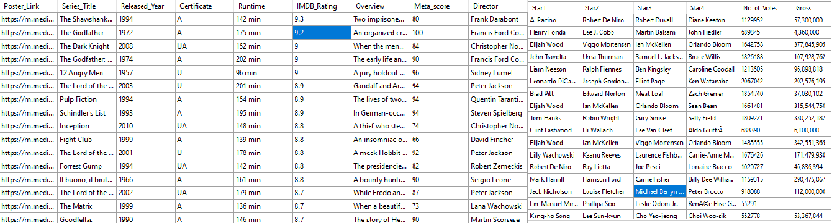

It is necessary to do an analysis of the functional dependencies (FDs) and multivalued dependencies (MVDs) contained within the database schema in order to ascertain whether or not the provided database schema is free from certain normal forms (3NF, BCNF, and 4NF).

Functional dependencies (FDs)

**Table “Movies”**

movie_id ->Poster_Link,Series_Title,Released_Year,Certificate,Runtime,Genre,IMDB_Rating,Overview,Meta_score,Director,Star1,Star2,Star3,Star4,No_of_Votes,Gross

**Table “Directors”**

Director_id -> DirectorName

**Table “Genres”**

Genre_id -> Genre

**Table “Stars”**

Star_id -> star_Name

**Table “Movie_genre**

Movie_id, genre_id -> Movie_id, genre_id

From the given Functional dependencies, it is observed that:

* All the attributed are atomic so schema satisfies 1NF.
* There are no partial dependencies so it satisfies 2NF.

Third Normal Form 3NF

In 3NF database is in 3NF if it is in 2NF. Each non-key column must function independently. If the table has dependent columns, create separate tables for each.

For testing that database is in 3NF let us test the following rules:

* Tables are in the 2NF.
* There is no transitive relationship between non-prime attributes of the tables.

Transitive Dependency

When there is a functional reliance that is not directly present between the attributes of the table, this type of relationship is referred to as transitive dependency. The term "transitive dependency" refers to the situation in which a table schema involves a dependency that is both A -> B and B -> C. To acquire Third Normal Form (3NF) Functional Dependency is required to eliminate. For this purpose tables are split.

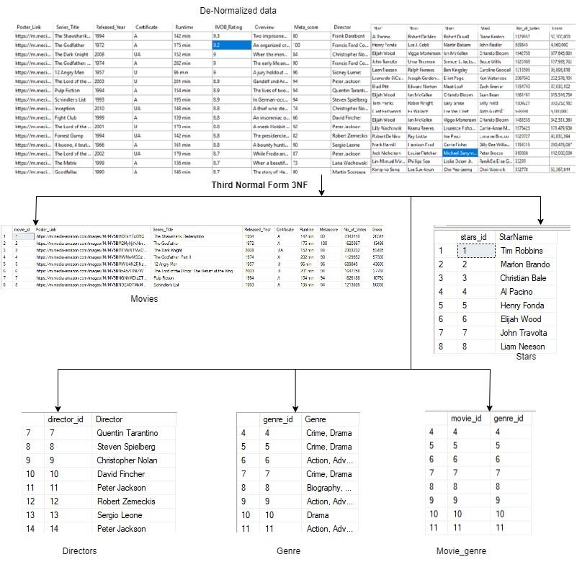

Boyce-Code Normal Form (BCNF)   
  
The functional dependencies are the focal point of BCNF when it comes to the relationships between things. If X is a super key of the relation, then the relation is said to be in BCNF. This holds true for every non-trivial functional dependency (X → Y). In circumstances in which X is not a candidate key, BCNF makes certain that there are no non-trivial functional dependencies currently in place.   
The candidate keys are the only non-trivial dependency, which is why the tables are already in the BCNF protocol. There are no other dependencies that are not trivial, and the primary key of each table is the only thing that can identify a row one-of-a-kind.

Forth Normal Form (4NF)

The use of 4NF allows for the management of relational dependencies that contain many values. When a relation is in BCNF and does not have any non-trivial multi-valued dependencies, it is deemed to be in 4NF. This is because 4NF is another name for BCNF. Within the context of a multi-valued dependency, each row in a table represents one of the numerous multi-valued relationships that exist independently.   
It is guaranteed that all tables are automatically in 4NF because BCNF does not have any dependencies that involve multiple values. In other words, this indicates that there is no dependence between any two tables in a manner that is not trivial, and that no one set of characteristics can be used to derive more than one set of values.

Relational Design of the Database after Normalization:

It shows that there are no duplication of data, transitive or functional dependency in the database and relations are split and have relationship between them with foreign keys.

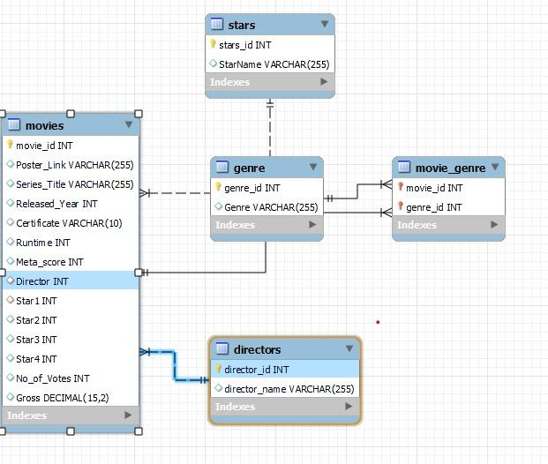

**Question No. 5**

**1- List all movies directed by a specific director (e.g., Steven Spielberg).**

SELECT Series_Title

FROM Movies

WHERE movie_id IN ( SELECT movie_id

FROM Directors

WHERE Director = 'Steven Spielberg');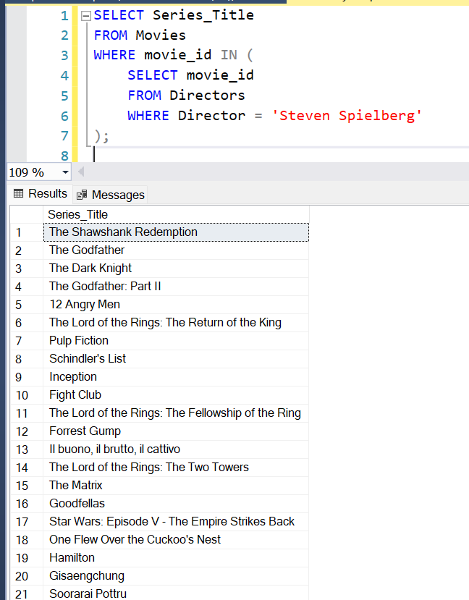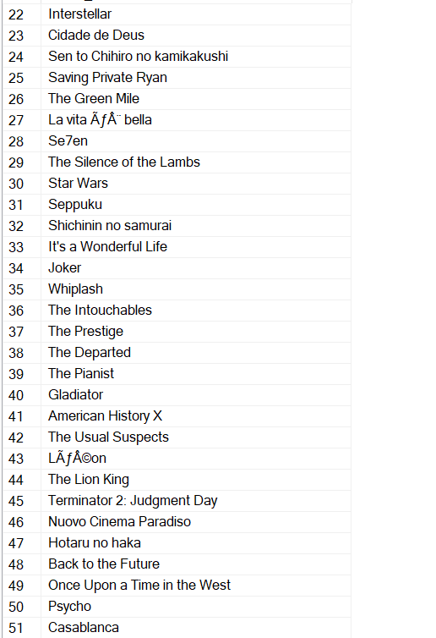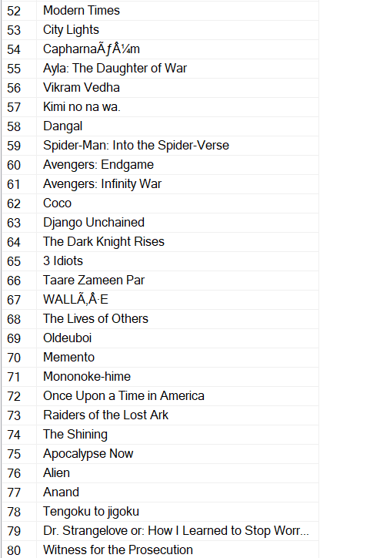

**2- Select stars who have appeared in movies with a gross income exceeding $100 million.**

SELECT StarName

FROM stars

WHERE stars_id IN ( SELECT stars_id

FROM Movies

WHERE Gross > 100000000);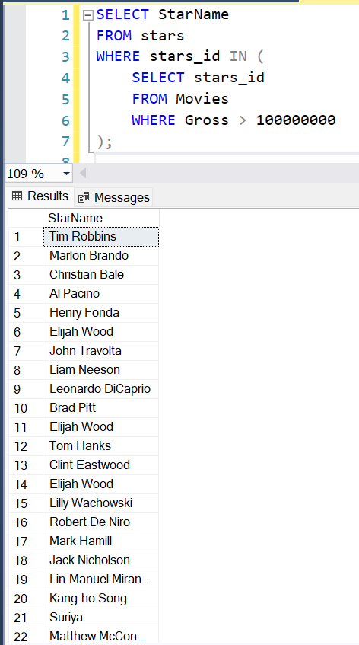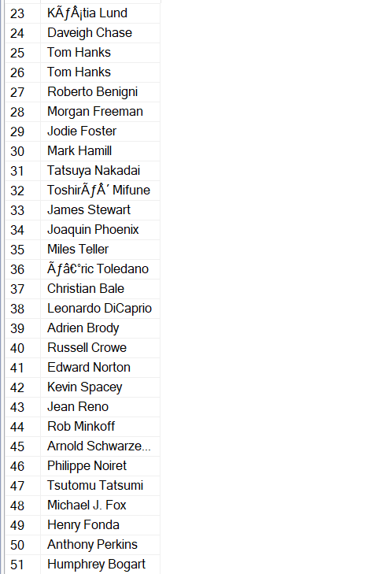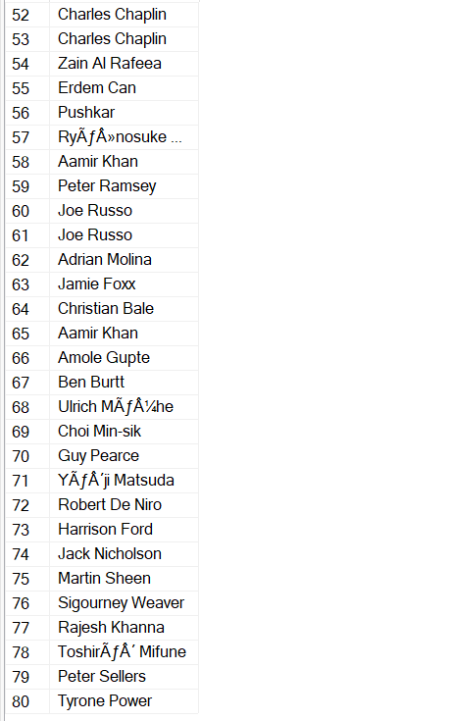

**3- Select directors who have directed movies with a Metascore above 80.**

SELECT Director

FROM Directors

WHERE director_id IN ( SELECT director_id

FROM Movies

WHERE Metascore > 80);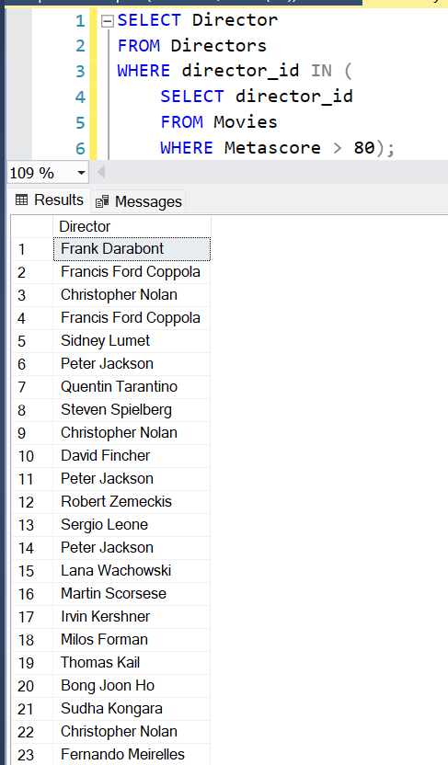

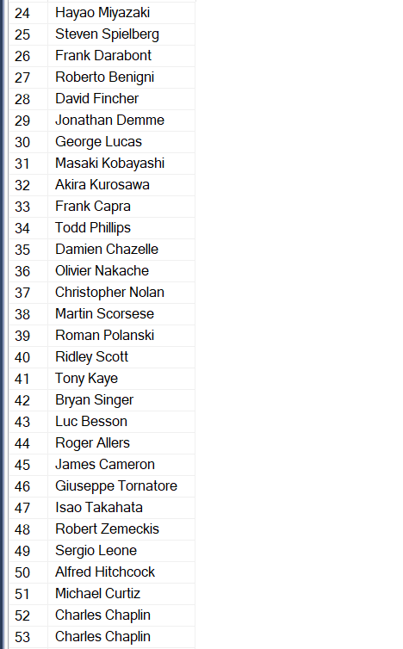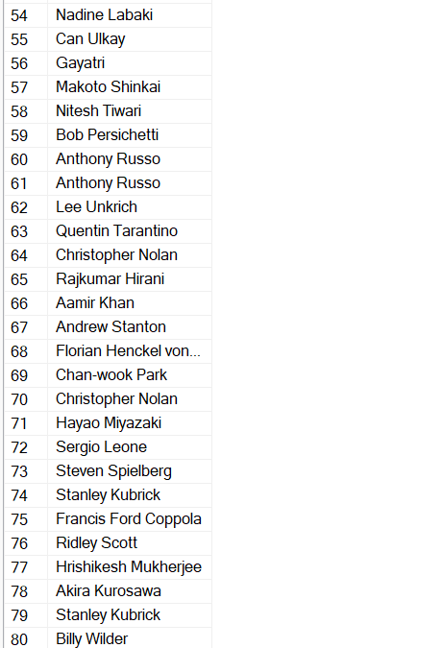

**4- Count the number of movies released each year.**

SELECT Released_Year, COUNT(*) AS MoviesCount

FROM Movies

GROUP BY Released_Year

ORDER BY Released_Year;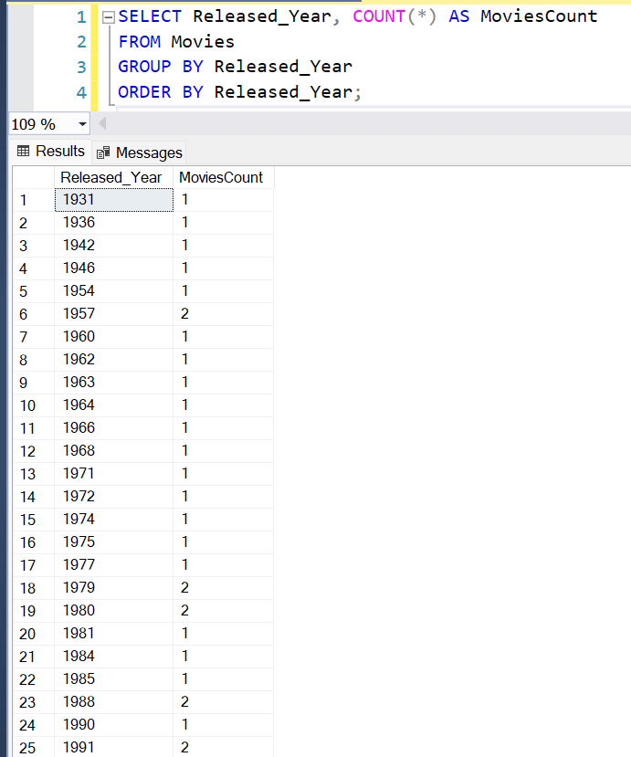

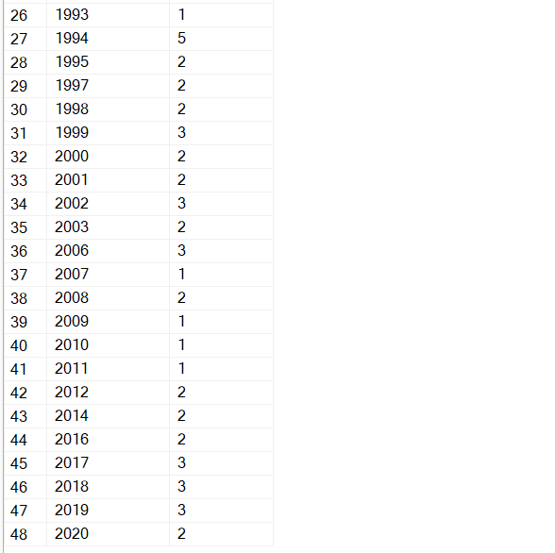

**5- Determine the highest-grossing movie for each certificate (if available).**

SELECT Certificate, Series_Title AS HighestGrossingMovie

FROM Movies

WHERE Gross = (

SELECT MAX(Gross)

FROM Movies

WHERE Certificate IS NOT NULL

GROUP BY Certificate

);

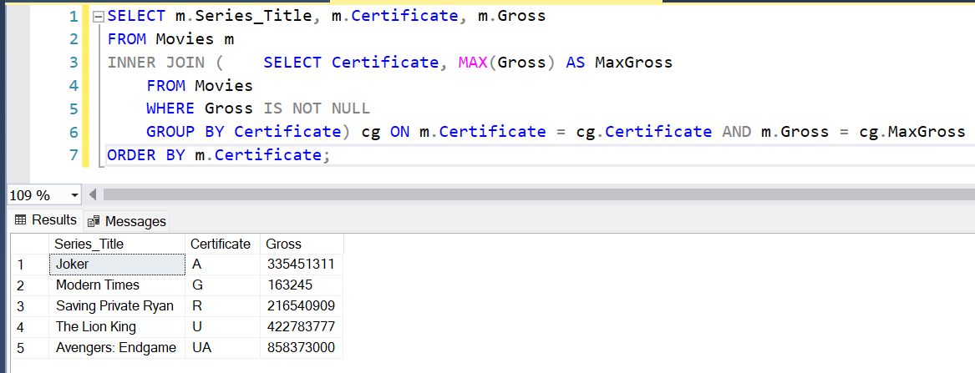

**6- Inserting a movie into the Movies table.**

INSERT INTO dbo.Movies (movie_id, Poster_Link, Series_Title, Released_Year, Certificate, Runtime, Metascore, No_of_Votes, Gross)

VALUES (99, 'https://example.com/poster.jpg', 'Inception', 2010, 'PG-13', '148 min', 74, 2000000, 829000000);

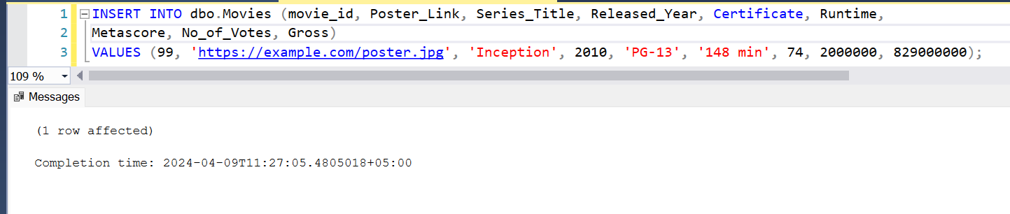

**7- Inserting a star into the Stars table.**

INSERT INTO dbo.stars (stars_id, StarName)

VALUES (99, 'Leonardo DiCaprio');

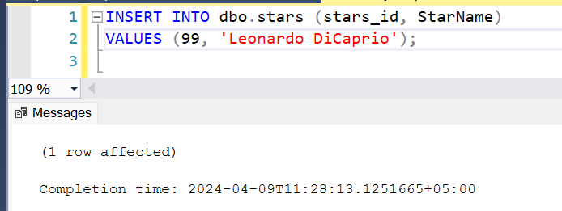

**8- Inserting a director into the Directors table.**

INSERT INTO dbo.Directors (director_id, Director)

VALUES (1, 'Christopher Nolan');

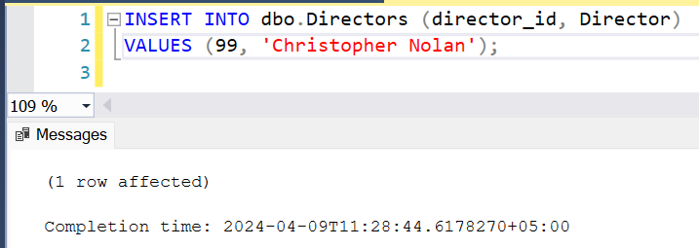

**9- Update the Metascore of a movie with ID 3 to 85.**

UPDATE dbo.Movies

SET Metascore = 85

WHERE movie_id = 3;

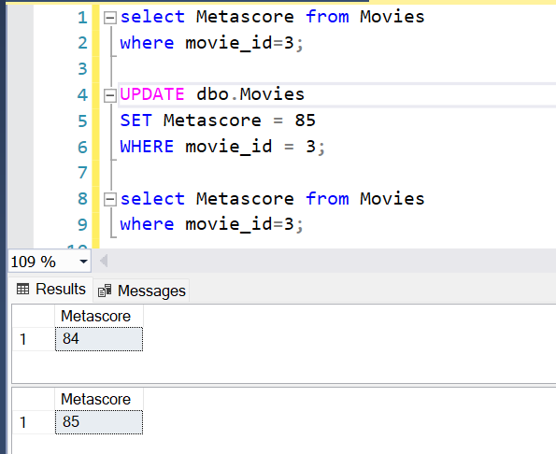

**10- Update the star name with ID 1 to "Leonardo DiCaprio".**

UPDATE dbo.stars

SET StarName = 'Leonardo DiCaprio'

WHERE stars_id = 1;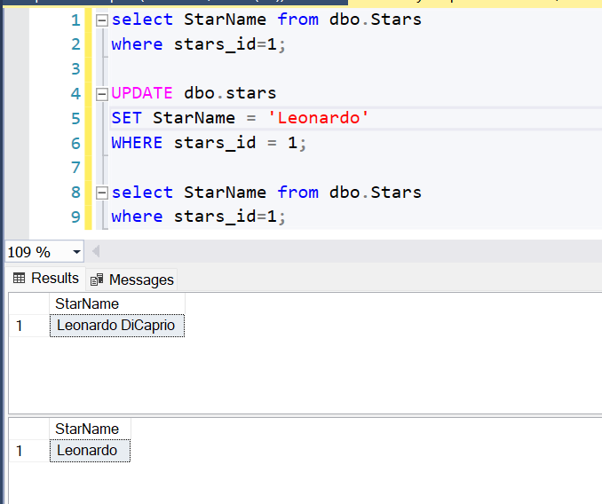

**6**

**Question No. 6**

This database, encircle movie information and related genres, smooth path for many application and use cases in the entertainment industry, data analysis, and decision-making processes.

Following are a few application/use cases designed to analyse data with queries:

1: Content Recommendation System

Utilizing movie attributes such as genre, IMDb rating, and viewer ratings, the database can power recommendation systems to suggest personalized movie recommendations to users of their own choice. Sql Queries includes:

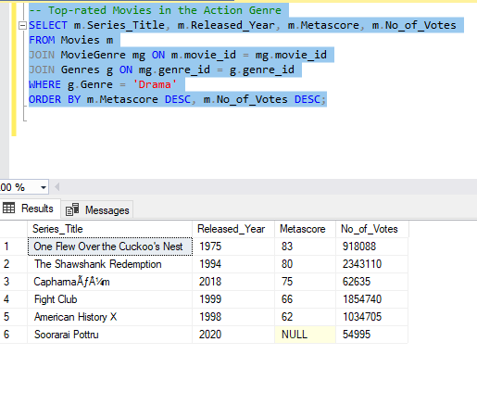

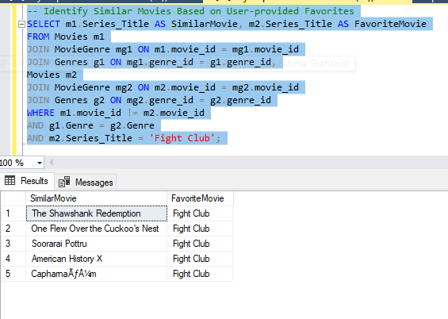

2 Market Trend Analysis

By the investigation of trends in movie releases, viewer ratings, performance over time, the database can give insights into market trends and audience choices. SQL Queries for this include:

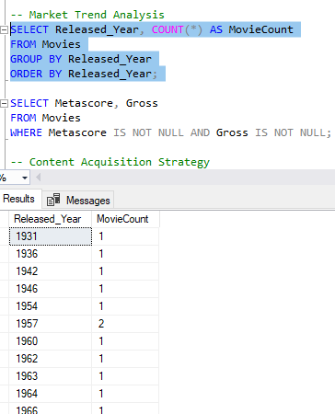

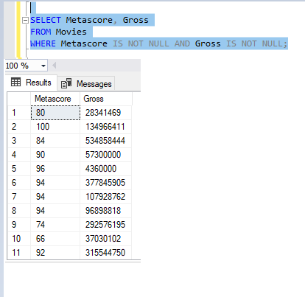

3: Content Acquisition Strategy

This database can be used be used by studios and streaming platforms to inform their content acquisition strategies by the identification of high-performing genres, directors, and stars. Queries for this include:

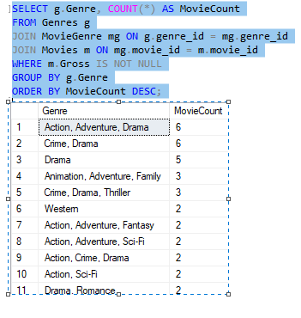

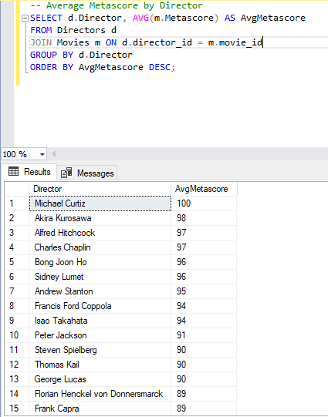

4: Performance Evaluation

Production companies can evaluate the performance of their movies by analysing acclamation, audience ratings, and financial metrics in the database.SQL Queries for this include:

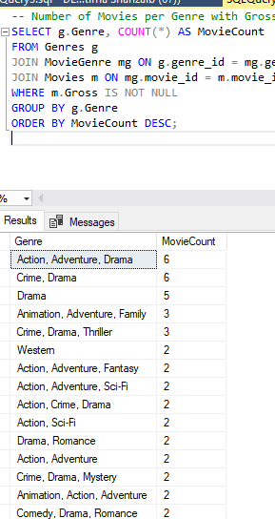

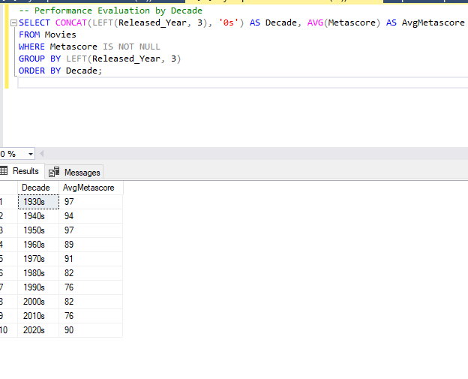

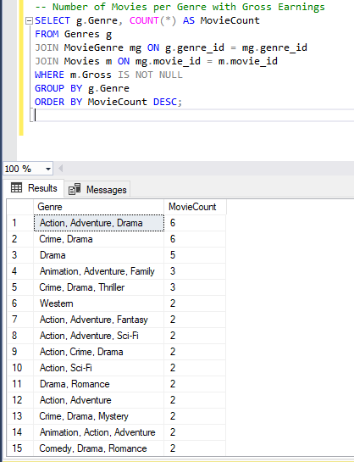

5: Content Licencing and Distribution

This database will be useful in content licencing and distribution. SQL queries included for this use case are:

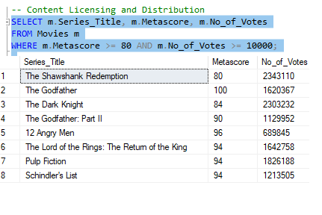

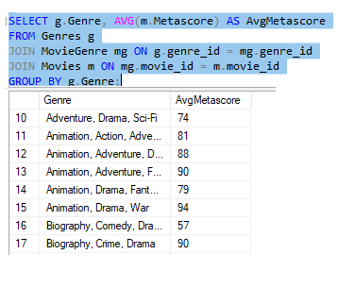

**7**

**Reference link for dataset:**

Shankhdhar, Harshit. (2021). IMDB Movies Dataset: Top 1000 Movies by IMDB Rating. Retrieved from [<https://www.kaggle.com/datasets/harshitshankhdhar/imdb-dataset-of-top-1000-movies-and-tv-shows>]